MODULE 1: EFFECTIVE QUESTIONS AND ANSWER |  |  | City/Region:  Venue: | Trainer:  Number of participants: | Date:  Time : 3 hours (180 minutes)
By the end of the module, participants will be able to:
- understand how different types of questions are used in teacher talk
- form beginner friendly questions
- scaffold students’ response in more comfortable and effective ways
- practice basic question forms and answers with students

The quote of the session:
“The teacher who asks questions about the topic is more helpful than the teacher who explains the topic”
James Clear

Language Point: Effective question and answer.
Skills: Speaking, Listening , Writing
Material: Videos, handouts, flipcharts

Stage/timing  Interaction | Activity type | Procedure
10 min  Pair work | Preview | Ask participants how they engage their students to participate in the lesson. How they make their students share their thoughts.  Participants share their experience about how they engage and make students communicate by using English.  Tell the participants to discuss the questions with elbow partners:  - What is the role of asking questions in the classroom?  - What part of the activity do you usually ask questions - in the beginning, when transitioning, or at the end of a lesson? Why is it your favorite?  - How helpful is asking questions in the class?  Elicit random answers.
15 min  The whole class | Apply | - Show the picture to participants and ask some questions.  - “Before you watch, what do you think this dialogue will be about?”  - “Before you watch, brainstorm what you think about this video.”  - “Look at this picture. What do you think about when you see this picture?”  Appendix 1  - Let trainees brainstorm and predict the video.  - Play the video Small Talk - YouTube and let participants watch half of the video. Pause the video in its half and by asking questions ask CCQ (Comprehension Checking Questions) check participants' ability of understanding the main idea of the video.  - “Is the old man the young boy’s grandad?”  - “Are they talking about the weather or love”?  - “Is the man single or married”? Why do you think so?  - Play the rest of the video.  - Discuss with participants about their prediction. Whether they were right or not with their prediction.
10 min  Individual work | Reflection | - Ask the participants to reflect on the listening and speaking integrated activity they have experienced by answering the following questions:  - Did you like this activity? Why?  - How did you feel during the activity?  - What have you learned from the activity?  - What is the role of asking questions in this activity?  - State that this is an example of engaging students to the class by asking questions in order to make them speak. Say that you used two techniques of asking questions like prediction and checking the understanding of the main idea. They also may use more questioning techniques like asking for specific information and making inferences and asking opinion. As you strive to establish asking effective questions and providing good answers toward a communicative language classroom environment, your students will increase in learning and use of the target language. This module will help you explore different techniques of effective questions and answers you can apply to your teaching context while using English. You will learn the purpose and examples of effective questions and answers to enhance the use of English in your communicative classroom.
25 minutes  Group work | Conceptualize  Video discussion | The participants will explore the ideas for effective questions and answers in English by watching two videos.  Video 1. “Asking Questions during Listening Tasks”  Tell the participants that this video will introduce some techniques of asking effective questions in English in pre-while-post activities.  Link to YouTube: TETE - Asking Questions During Listening Tasks - YouTube  Video 2. “Practicing Wh-Questions using Information Gap Activities”  Tell the participants that this video will show you an example of how to lead your students to form and use basic wh-questions in classroom activities.  Link to YouTube: TETE - Practicing Wh Questions Using Information Gap Activities - YouTube
30 min  Group work | Apply | Tell trainees they will be designing open-ended Wh-questions and changing some of them to Yes/No response questions.  - Review Wh-questions and Yes/No response questions with tranees.  - Provide a list of Wh - Questions and stick on the board.  - Divide the class into two groups.  - Ask groups to read the passage. Appendix 2  - Ask groups to make Wh -questions based on topic.  - Have groups exchange developed questions and answer the questions of the partner group.  - Tell trainees to change some open - ended response questions to Yes/No response questions on the table in Handout 1 . (sample is in Appendix 3)  - Provide constructive feedback.
40 min  Group work | Conceptualize  Jig-saw Reading | Home group - Guest Group – Home group.  Group 1. CREATING OR ADAPTING BEGINNER-FRIENDLY QUESTIONS  Group 2. INCREASING WAIT TIME  Group 3. NON-TRADITIONAL STUDENT RESPONSES  - Divide the participants into three groups. Tell them that this is their Home group. They will read the assigned article Questions and Responses and discuss it in their groups. They should take notes on the table. (15 minutes)  - Number the participants from 1 to … . tell them to show their number with fingers and keep their fingers up to find their group. All the participants who are number one will form one group, all the twos will form group two, so on.  - When group members meet in the guest group (new group) they share the information they discussed in their host groups. Tell the participants to take notes on the table. (10 minutes) (Handout 2)  - Ask the participants to go back to their home groups with their notes and share their findings. (10 min)  - Ask the groups to share what they have learned about routine activities. Elicit random responses. (5min)
15 min  Pair work | Reflect/ Experience  Mingle around activity | Ask the participants to discuss the following questions by referring to the videos and articles they discussed. Read the questions and tell them to write the answer in their notebooks. (1 minute)  - Which of the suggested effective questions and answers do you think can be adaptable to your teaching context? Why and why not?  - How do you plan to apply them into your classroom?  When you see the participants are ready, tell them:  - “Now, walk around the room to find a partner to share what you wrote. Please, talk at least to two peers”  - “As you listen, write down what your partner said in your notebook.”  As you mingle around the room and listen to their conversations, you can check for participants’ understanding of the session videos and articles.
5 min  The whole class | Discussion | If you have some time you may ask participants to reflect on the quote of the session:  “The teacher who asks questions about the topic is more helpful than the teacher who explains the topic” James Clear  - How do you understand this quote?  - Do you agree? Why?
10 min  The whole class | Wrap-up | For the wrap up at the end of the session, you can go to objectives and ask questions:  - Do you understand how different types of questions are used in teacher talk  - Can you form beginner friendly questions? Any examples please?  - Can you scaffold students’ responses in more comfortable and effective ways? How?  - Have you practiced basic question forms and answers during the sessions? How?
5 min | Homework  Telegram group discussion | Choose a part (reading or listening) in your textbook and create a set of questions that fits for the learning goal of the part you’ve selected. Think about a possible question and answer situation that might happen in that learning sequence. Use the tasks and languages for different goals you have watched and read in the module such as an information gap activity.  Post your reflection in the Telegram group. Read your peers’ posts and comment at least to two posts by using the ‘reply’ function in the Telegram chat.

Appendix 1
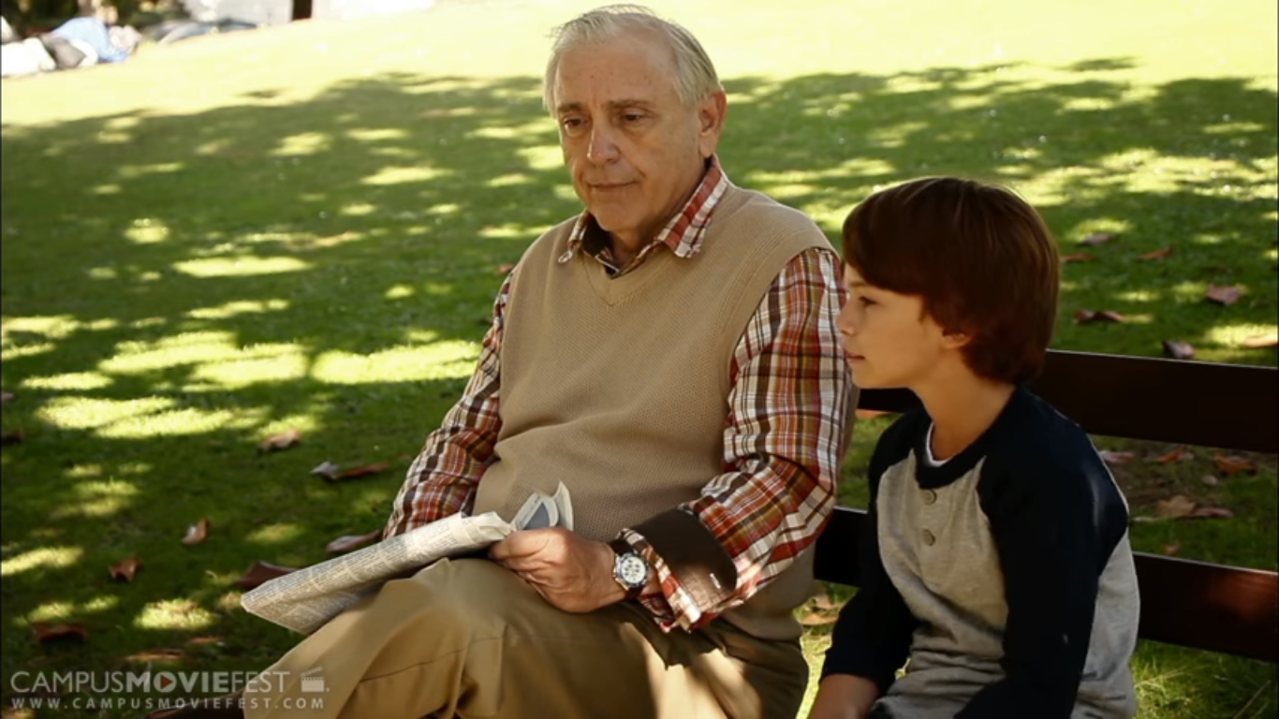

Appendix 2
Source : Teens 8 (page 20)

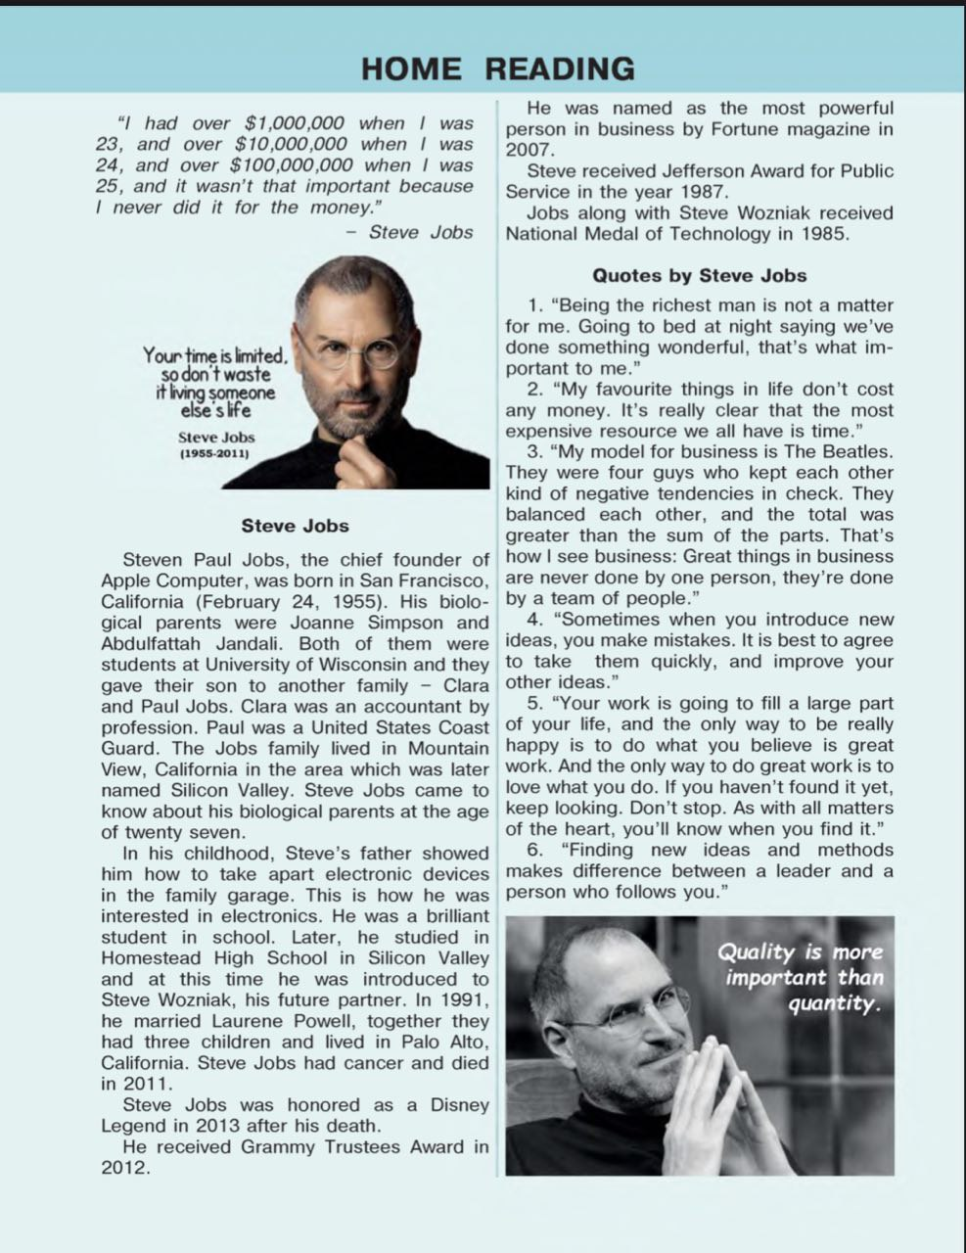

Appendix 3.

Open-Ended Response | Yes/No Response
What characteristics tell you that an animal is a mammal? | Is this animal (in the picture) a mammal?
How do you know a shape is a rectangle? | Does a rectangle have four sides?
What is the weather like today? | Is the weather sunny today?
What foods do you like to eat? | Do you like to eat eggs? Rice? Fish?

Handout 1

Open-Ended Response | Yes/No Response

Handout 2

Articles | Key points from the articles
CREATING OR ADAPTING BEGINNER-FRIENDLY QUESTIONS

INCREASING WAIT TIME

NON-TRADITIONAL STUDENT RESPONSES

