6 Principles

1. Introduction to the 6 Principles

2. Principle 1: Know your learners
Agenda
8:30- 9:00 | Intro to 6 Principles
9:00 - 9:10 | Intro to 6 Principles
9:10 - 9:40 | Intro to 6 Principles
10:00 - 10:30 | Intro to 6 Principles
10:45 - 12:00 | Principle 1
12:00 - 12:40 | Principle 1
12:40- 1:00 | Principle 1

Welcome Message
Good morning dear Colleagues,

Our team is pleased to have you with us. On behalf of all the organizers, coordinators, coaches of this project let us say Congratulations and welcome to the team!

Today, together with you we are going to start the next stage of this project, which will create an opportunity to enrich and enlarge your knowledge and skills in teaching English effectively. Together with you we are a great and strong team.
We believe that what a strong group of people can accomplish together is much larger, far greater, and will exceed what an individual can achieve alone.
Workshop Objectives

By the end of the workshop I can…

- understand the general purpose of this workshop.

- say the general notion and the concept of the 6Ps.

- prepare and deliver lessons effectively concerning the learners interest.

- learn how to use activities for creating friendly learning atmosphere

Lesson Plan

MODULE:Introduction to the 6 Principles for  Exemplary Teaching of English Learners |  |  | Date:  Time : 3 hours (180 minutes)
By the end of the module, participants will be able to:
- understand the general notion and concept of the 6 Principles for Exemplary Teaching of English Learners;
- practice and analyze activities addressing to collect information about their learners to engage them in class
- prepare and deliver lessons more effectively basing on the interests of their learners;
- identify what makes the learning atmosphere friendly and supportive;
- experience activities which make a good learning atmosphere.
Language Point: General Concept and terms of the 6 Principles: Principle 1 and 2
Skills: Speaking, Listening , Writing
Material: Videos, handouts, flipcharts

Session 1. Overview of The 6 Principles for Exemplary Teaching of English Learners
Time: 1 hour (60 minutes)
Stage/timing  Interaction | Activity type | Procedure
15 min  Snowball: Name+Adjective | Warm-up | - Ask participants to make a circle.  - Ask them to find an adjective they think describes them best of all or just an adjective which starts with the same letter as their name.  - Give your own example. eg. Makhprat – modest. Give them 1 minute to think.  - Check they all found an adjective, then explain the next stage and start a game.  - Show the image of adjectives on the ppt  Direction:  -Trainer asks all participants to stand up in a circle.  - Trainer says his/her name and adds an adjective. E.g. Makhprat – modest. Then turns to the next participant.  - The second participant should repeat the trainer’s name + adjective and add his/her own name + adjective. E.g. Makhprat – modest. Inomiddin – intelligent.  - The next participant should repeat the trainer’s name + adjective, the name of the previous participant + adjective and add their own name + adjective etc.  Note You can ask participants to repeat in chorus after each person. (e.g. Makhprat – modest./Inomiddin – inteligent. Izzat – impatient. etc.)  Ask participants to go back to their seats. Sum up the activity by writing these questions in the ppt and chorally reading one as a class and choose a few people to share. Next read the next question chorally together.  1. How did you feel during the activity?  2. Did you have any difficulties? If so, why?  3. Do you think your pupils will enjoy the activity?  4. What were the objectives of the activity?  Answers will be varying. Accept all the answers.
7 minutes | Class Rules | Class Rules  How to establish ground rules for our class. What rules do you want to be part of this training ?  Such as masks on, speaking one at a time, coming on time, doing all H.W. you can have the class come up with it, but it would be nice to have to do this and all sign it or agree with it somehow. It’s a team building activity.  All can draw an outline of their hand and write their name in the middle with a signature.
10 min Introduction to the workshop | Preview | Introduction to the workshop.  - Trainer gives brief information about the workshop objectives.  - Then distribute colored stickers and ask participants to write 1 thing they have known and 1 expectation from this workshop.  Ask them to stick their paper in the basket. (The basket drawn on a large poster and hang on the wall)
15 min  Pair work | Activity. Scavenger Hunt | 1. Introducing the Scavenger Hunt activity. Tell participants the purpose is to introduce new vocabulary related to The 6 Ps.  2. Direct participants to the Scavenger Hunt handout.  3. Discuss the directions for the activity.  4. When I give you a signal, walk around the room for five minutes. Ask other people the meanings of the vocabulary you do not know.  5. Sit down when you finish or when I give you a signal.  1. Model the activity by going to one person and asking them, “Do you know what…. means?”  Do a think-aloud as you fill in one box and ask someone about another box:  * OK, I know what “EFL” is. It’s English as a foreign language (write definition in its box).  * Hmmm, I’m not sure what “community of practice” means. _____, what do you think “community of practice” means?  2. Give participants 5 minutes to complete the activity as you monitor and assist.  Have participants check the PPT for suggested meanings and answer any questions they have:  PPT: The 6 Principles for Exemplary Teaching of English Learners  Overview. Slides: 5-6.
20 min  Individual/ Pair work | Introduction to the 6 Ps  Overview Think-Pair-Share | - Direct Ps to the Overview of the 6 Ps handout .  - Show participants The 6 Ps image.  - Ask them, “Why do you think the 6 Ps is designed in a circle with 6 parts?  - Give them time to read each Principle and highlight the words and given definitions based on the previous activity.  - Introduce The 6 Principles for Exemplary Teaching of English Learners  - Explain that the center of The 6 Ps is “Know your learners” (Principle 1) and that “Engage and collaborate within a community of practice” (Principle 6) is what holds The 6 Ps together.  - Explain why TESOL International developed The 6 Ps concepts, but it’s possible that teachers may already be using some of these principles in how they teach.  - Our goal in this course is to help teachers use them more intentionally and purposely.  - Distribute Handout # 3 (one for each table). Ask participants to watch the video and take a note for answering the questions. Ask them to write their opinion basing on their own understanding, then share ideas with their group.  - Invite one participant from each group to present their group answers for the question.  - Elicit their answers.  - Have participants read the quote and then discuss how we make this possible when we use The 6 Ps together.  - Quote:“Knowledge of more than one language and culture is advantageous for all students.”  - Use PPT: Overview of the 6 Ps slides : 9-10; 11-13.handout (#2 and #3) (We can use PPT slide and The 6 Ps Introductory Video )  - Link to the 6Ps Introductory video: https://youtu.be/Azt9iC6qYsA  Use PPT: Overview of the 6 Ps slides : 9-10; 11-13.handout (#2)
10 mins  Individual /pair work | Reflection | - Ask the participants to reflect on the sample activity they have experienced by answering the following questions:  - Did you like this activity? Why?  - How did you feel during the activity?  - What have you learned from the activity?  Elicit their answers  State that this is an example of activity. Say that effective classrooms …
 |  | 10 minutes break

Week 1. Session 2. Principle 1: Know your Learners
Principle 1
Activity: Stand Up / Sit Down  Trainer(s): _________ | 10” | - Introduce the Stand Up / Sit Down activity. Tell participants the purpose is to use a community building activity to get to know some things about each other. Tell them to be thinking about how they could adapt the activity for their own classroom (community building or skill based).  - Discuss the directions for the activity.  1. Listen to and/or read each statement. If it is true for you, stand up. If it is not true for you, sit down.  2. Look around so you can learn new information about your colleagues.  3. EXTENSION: Ask follow-up questions to people near you.  - Model the activity with these statements.  1. I live in the United States.  2. I have taught English for more than 25 years.  3. I have a pet.  - Monitor and assist with the activity.  Stand up if you . . .  - like to visit new places.  - have a passport.  - have traveled by plane.  - have visited the United States.  - would like to travel to space.  - can stand on one foot for 10 seconds (show us!) | PPT 18
Activity: Turn and Talk / Activity Tracker | 10” | - Re-introduce the Turn and Talk / Activity Tracker activity. Model:  Do a think-aloud as you answer each of the four questions:  * What did we do? We stood up for sentences that were true. We sat down for sentences that were false.  * How did we do it? We did this in a large group. We listened to and/or read statements and stood up for true statements and sat down for false statements.  * Why did we do it? It was a good community building activity. I learned new things about people in my group.  * How can I adapt this activity to use in my classroom? 1) I could use this as a comprehension check activity after a reading or listening activity. 2) I could  - use this to check student understanding of facts vs. opinions. 3) etc.  - Emphasize the importance of ongoing community building with activities such as these.  - Give participants 5 minutes to complete the activity as you monitor and assist. | - Activity Tracker handout | PPT 22
What Teachers Need to Make Effective English Lessons? | 10 | - Ask the teachers, what do you think teachers need to have an effective lesson?  - Tell participants we are going to discuss the top three things teachers need to make effective English lessons. | PPT 27
Principle 1: Know Your Learners | 5” | - Introduce Principle 1: Know your learners.  - Discuss how teachers teach best when they know their students well. | - PPT 32
Principle 1 – Best Practice 1: Teachers collect information about their students. | 5” | - Introduce Best Practice 1: Teachers collect information about their students.  - Discuss examples of the kinds of information teachers can collect about their students (prior knowledge, talents, interests, life experiences, influences, characteristics of specific age groups).  - Finish with characteristics of specific age groups as you transition into the next activity. | - PPT 33-34
Characteristics of Specific Age Groups  Trainer(s): _________ | 5” | - Briefly show the five age groups we will discuss. Explain that we can only teach children well if we have a deep understanding of their unique characteristics and stages of development: physical, cognitive, and social-emotional.  - Emphasize that the more we know about students’ physical, cognitive, and social-emotional stages, the better we can choose appropriate activities and materials for the best learning experiences.  - Remind participants that this is only a general guide. Many factors affect students’ physical, cognitive, and social-emotional growth. | - PPT 35–36
Activity: Jigsaw Reading  Trainer(s): _________ | 20” | - Direct participants to the Jigsaw Reading handout which corresponds with their Numbered Heads Together group (group number is in the top right corner of the handout).  - Have participants divide into their Numbered Heads Together groups. Divide each group into subgroups as necessary to make groups of a manageable size.  - Remind participants they will become the “experts” for their assigned age group. This will make each of them an important piece in the puzzle. In their groups, they will read, discuss, and clarify meaning for the physical, cognitive, and social-emotional characteristics of their assigned group for 15 minutes.  - Monitor and assist with the activity.  - After 15 minutes, tell participants to return to their table groups.  - Ask groups to report their findings. | - PPT 37 NOTE: PPT 41-56 are only for reference as/if needed  - Jigsaw Reading handout
Activity: Turn and Talk / Activity Tracker: Jigsaw Reading and Jigsaw Note Taking  Trainer(s): _________ | 5” | - Re-introduce the Turn and Talk / Activity Tracker activity.  - Give participants 5 minutes to complete the activity as you monitor and assist.  - Ask participants to share out as time allows. | - PPT 57–58  - Activity Tracker handout
Activity: Thumbs Up / Thumbs Down  Trainer(s): _________ | 5” | - Introduce the Thumbs Up / Thumbs Down activity.  - Show and read one statement at a time and ask participants to respond with a thumbs up for “true” statements and a “thumbs down” for false statements..  1. The 6 Principles come from three years of research. (False – They come from many years (decades) of research.)  2. We can learn about characteristics of children at different age groups by looking at their physical, cognitive, and social-emotional stages. (True)  3. A jigsaw activity is a good way for students to help each other build comprehension in a small group. (True)  - Remind participants that using methods with similar directions (Response Cards) can help students feel more comfortable and help with classroom management. | - PPT 99–60
Principle 1 – Best Practice 2: Teachers plan lessons to collect and use information about students. | 5” | - Introduce Best Practice 2: Teachers plan lessons to collect and use information about students.  - Discuss examples of the kinds of lessons teachers can plan to collect information about their students (games and warm-up activities, questionnaires, needs assessments, interest and background inventories, observation checklists, one-on-one discussion, picture stories, autobiography projects).  - Ask participants to share other ideas. | - PPT 61–62

Week 2

Principle 2: Create conditions for language learning

Week 2 Agenda
8:30 - 9:00 | Principle 2
9:00 - 9:10 | Principle 2
9:10 - 9:40 | Principle 2
10:00 - 10:30 | Principle 2
10:40 - 12:00 | Principle 3
12:00 - 12:40 | Principle 3
12:40- 1:00 | Principle 3

Welcome Message

Good morning dear Colleagues,

Our team is pleased to have you with us. On behalf of all the organizers, coordinators, coaches of this project let us say Congratulations and welcome to the team!

Today, together with you we are going to start the next stage of this project, which will create an opportunity to enrich and enlarge your knowledge and skills in teaching English effectively. Together with you we are a great and strong team.
We believe that what a strong group of people can accomplish together is much larger, far greater, and will exceed what an individual can achieve alone.

Workshop Objectives

By the end of the workshop I can…
- Design high quality lessons with clear objectives
- Give clear oral and written English that students can understand.
- Organize active classrooms where students can actively practice English

Week 2. Session 1. Principle 2: Create conditions for language learning
Principle 2
Activity: Personal Inventory  Trainer(s): _________ | 10” | 1. Direct participants to the Personal Inventory handout.  2. Tell participants that the purpose of this activity is to give them some time for self-reflection before we move on with Principle 2.  3. Discuss the directions for the activity.  1. Read each statement.  2. Rate yourself with the following criteria:  ● A – always or almost always  ● S – sometimes  ● N – never or almost never  3. Put a star (★) next to the three statements you most want to improve on.  4. Model the activity by doing a think-aloud.  * I greet students as a group at the beginning of class, and I greet a few of them individually if they arrive early. I’ll write “S” for “sometimes.”  * I never use community-building tasks. Actually this is a new idea for me. I’m interested in the idea, but right now, I have to write “N” for “never.” I’m going to put a star next to that one because I definitely want to improve on that.  5. Tell participants they can work with their table group to clarify meaning, but it is not necessary to share their responses with one another.  6. Monitor and assist with the activity.  7. Ask participants to keep the Personal Inventory out and available for quick reference as we explore Principle 2. | PPT 67-68  Personal Inventory handout
Activity: Think-Pair-Share | 10 | 1. Introduce Think-Pair-Share as a tool for discussion.  2. Discuss the directions for the activity.  1. Think about the question that you hear and/or read.  2. Pair with a partner, and discuss your answers.  3. Share in a larger group.  1. Model a Think-Pair-Share response to the question “What are some activities that we have done today that could motivate students in my classroom?”  2. Ask participants to form Think-Pair-Share groups at their tables.  Tell participants that we will use Think-Pair-Share as a technique to discuss Principle 2. | PPT 69-71
Principle 2 – Best Practice 1: Teachers create a positive and organized classroom where students feel happy and comfortable.  Trainer(s): _________ | 10 | 1. Introduce Best Practice 1: Teachers create a positive and organized classroom where students feel happy and comfortable.  2. Ask participants to use Think-Pair-Share to respond to the question prompt for 3 minutes.  * What are some ways you can create a positive and organized classroom where students feel happy and comfortable?  3. Have participants share out as time allows.  Have participants look back at Questions 1–10 on their Personal Inventory to see how their responses correspond with examples of Best Practice 1. | ● PPT 94–96  ● Personal Inventory handout
Principle 2 – Best Practice 2: Teachers demonstrate that they have high expectations of all students.  Trainer(s): _________ | 10” | 1. Introduce Best Practice 2: Teachers demonstrate that they have high expectations of all students.  2. Ask participants to use Think-Pair-Share to respond to the question prompt for 3 minutes.  3. Have participants share out as time allows.  Have participants look back at Questions 11–15 on their Personal Inventory to see how their responses correspond with examples of Best Practice 2. | - ● PPT 97–99  - Personal Inventory handout
Principle 2 – Best Practice 3: Teachers plan lessons that motivate students.  Trainer(s): _________ | 5” | - Introduce Best Practice 1: Teachers collect information about their students.  - Discuss examples of the kinds of information teachers can collect about their students (prior knowledge, talents, interests, life experiences, influences, characteristics of specific age groups).  - Finish with characteristics of specific age groups as you transition into the next activity. | - PPT 33-34
Characteristics of Specific Age Groups  Trainer(s): _________ | 5” | - Briefly show the five age groups we will discuss. Explain that we can only teach children well if we have a deep understanding of their unique characteristics and stages of development: physical, cognitive, and social-emotional.  - Emphasize that the more we know about students’ physical, cognitive, and social-emotional stages, the better we can choose appropriate activities and materials for the best learning experiences.  - Remind participants that this is only a general guide. Many factors affect students’ physical, cognitive, and social-emotional growth. | - PPT 35–36
Activity: Jigsaw Reading  Trainer(s): _________ | 20” | - Direct participants to the Jigsaw Reading handout which corresponds with their Numbered Heads Together group (group number is in the top right corner of the handout).  - Have participants divide into their Numbered Heads Together groups. Divide each group into subgroups as necessary to make groups of a manageable size.  - Remind participants they will become the “experts” for their assigned age group. This will make each of them an important piece in the puzzle. In their groups, they will read, discuss, and clarify meaning for the physical, cognitive, and social-emotional characteristics of their assigned group for 15 minutes.  - Monitor and assist with the activity.  - After 15 minutes, tell participants to return to their table groups.  - Ask groups to report their findings. | - PPT 37 NOTE: PPT 41-56 are only for reference as/if needed  - Jigsaw Reading handout
Activity: Turn and Talk / Activity Tracker: Jigsaw Reading and Jigsaw Note Taking  Trainer(s): _________ | 5” | - Re-introduce the Turn and Talk / Activity Tracker activity.  - Give participants 5 minutes to complete the activity as you monitor and assist.  - Ask participants to share out as time allows. | - PPT 57–58  - Activity Tracker handout
Activity: Thumbs Up / Thumbs Down  Trainer(s): _________ | 5” | - Introduce the Thumbs Up / Thumbs Down activity.  - Show and read one statement at a time and ask participants to respond with a thumbs up for “true” statements and a “thumbs down” for false statements..  1. The 6 Principles come from three years of research. (False – They come from many years (decades) of research.)  2. We can learn about characteristics of children at different age groups by looking at their physical, cognitive, and social-emotional stages. (True)  3. A jigsaw activity is a good way for students to help each other build comprehension in a small group. (True)  - Remind participants that using methods with similar directions (Response Cards) can help students feel more comfortable and help with classroom management. | - PPT 99–60
Principle 1 – Best Practice 2: Teachers plan lessons to collect and use information about students. | 5” | - Introduce Best Practice 2: Teachers plan lessons to collect and use information about students.  - Discuss examples of the kinds of lessons teachers can plan to collect information about their students (games and warm-up activities, questionnaires, needs assessments, interest and background inventories, observation checklists, one-on-one discussion, picture stories, autobiography projects).  - Ask participants to share other ideas. | - PPT 61–62

Lesson Plan

Principle 3: Design high-quality language lessons
MODULE :
Design high-quality language lessons
By the end of the module, participants will be able to:
- Design high quality lessons with clear objectives
- Give clear oral and written English that students can understand.
- Organize active classrooms where students can actively practice English
Language Point:
Skills: Speaking, Listening , Writing
Material: Videos, handouts, flipcharts
Stage/timing  Interaction | Activity type | Procedure
15 min  Welcome  Routines | Warm-up | - Give a general welcome to Day 2 of the 2-day workshop.  - Announce any “housekeeping items” if necessary.  - Change table groups. Have participants introduce themselves to the other members of their new table-group.  Note: Change table groups. (quickly). Use a line up by birthday or other way to mix groups
5 min  Introduction to Principle 3 | Today’s Objectives | Present the objectives for Day 2
15 min  Group work | Activity: Penny for Your Thoughts | - Introduce the Penny for Your Thoughts activity. Tell participants the purpose is to use a community building activity to get to know some things about each other. Tell them to be thinking about how they could adapt the activity for their own classroom (community building or skill based).  - Direct participants to the pennies on their table.  - Discuss the directions for the activity.  1. Pick up a penny on your table.  2. Look at the year it was produced.  3. Think of an important event in your life from that year that you feel comfortable sharing with others (if it is a year before you were born, you can exchange your penny with another person).  4. Share the event with your table-group.  - Model the activity by doing a think-aloud with two different pennies.  * My penny is from 2001. That was an important year for me because I graduated from university that year and got my first teaching job.  * 1987, well, that was a few years before I was born, but it is still an important year in my life because it’s the year my parents got married.  - Monitor and assist with the activity.  - Ask participants to share out interesting events as/if time allows.  - Emphasize the importance of ongoing community building with activities such as these.  Notes: at least one penny per participant;  Put pennies on the tables before the workshop.
10 min  Individual work | Activity: Turn and Talk / Activity Tracker: Penny for Your Thoughts | - Re-introduce the Turn and Talk / Activity Tracker activity. Have them refer to the Activity Tracker handout from Day 1.  - Give participants 5 minutes to complete the activity as you monitor and assist.  - Ask participants to share out as time allows.  Notes: Activity Tracker handout
25 minutes  Group work | Conceptualize | The participants will explore the ideas for by watching :  Video on PPT page 114
40 min  Group work | Activity 3-2-1 | - Best Practice 1: Teachers prepare lessons with clear language objectives and share the objectives with their students.  - Best Practice 2: Teachers use oral and written English that students can understand.  - Best Practice 3: Teachers have active classrooms where students can actively practice English with interesting topics.  - Write the name of your assigned region of Uzbekistan.  - Work with your table-group to add the 3-2-1 information in the boxes.  - Transfer all of the information to poster paper.  - Be ready to answer questions about your region and ask questions about other groups’ regions. You can add drawings if you like. (Handout 1).
10 min  Pair or group work | Wrap-up | Review: Retell your partner what you learned about Principles 1-3. How did we facilitate your learning today?  Extend: 6Ps Resources Graphic Organizer, What other activities do you know that might support each principle? Add a few to the notes column.  Reflect: What questions do you have? What connections are you making between The 6Ps and your teaching?

Section and Trainer(s) | Time | Instructions | Materials | Notes
Overview of the 6 Principles
Welcome and Introductions | 3” | - Briefly introduce each TESOL Trainer with name and home base.  - Tell Ps we will provide a brief overview of the 6 Principles, which we will learn about in Days 2 and 3. | - PPT 1-2 | These 6Ps materials were developed to be accessible to teachers with developing English levels. Many activities may be familiar to CTs and RPMs. This is for them to learn then cascade. They will not recreate the TOT, rather train on aspects of 6 Ps.
Activity: Scavenger Hunt  Trainer(s): _________ | 15” | - Introduce the Scavenger Hunt activity. Tell participants the purpose is to introduce new vocabulary related to The 6 Ps.  - Direct participants to the Scavenger Hunt handout.  - Discuss the directions for the activity.  1. Look at the vocabulary word in each box on this paper.  2. Write a note about the meaning of each vocabulary word that you know.  3. When I give you a signal, walk around the room for five minutes. Ask other people the meanings of the vocabulary you do not know.  4. Sit down when you finish or when I give you a signal.  - Model the activity.  Do a think-aloud as you fill in one box and ask someone about another box:  * OK, I know what “EFL” is. It’s English as a foreign language (write definition in its box).  * Hmmm, I’m not sure what “community of practice” means. _____, what do you think “community of practice” means?  - Give participants 5 minutes to complete the activity as you monitor and assist.  - Have participants check the PPT for suggested meanings and answer any questions they have:  * EFL – English as a Foreign Language  * TESOL – Teachers of English to Speakers of Other Languages  * exemplary – excellent, model, very good, perfect  * principles – truths, beliefs  * community of practice – a group of people who do the same thing and work together to do it better  * resources – tools, materials, supports  * learners – students  * conditions – situations, environment, circumstances  * lesson delivery – how teachers present a lesson  * adapt – change, adjust, modify  * create – make, develop, design  * design – plan, create, make  * monitor – observe, watch, check  * assess – evaluate, determine, judge  * engage – participate in, join in  * collaborate – work with, cooperate with | - PPT 3–6  - Scavenger Hunt handout
Activity: Turn and Talk / Activity Tracker: Scavenger Hunt  Trainer(s): _________ | 15” | - Introduce the Turn and Talk / Activity Tracker activity. Tell participants the purpose is to give them time to think about and take notes on each activity in the two-day workshop.  - Direct participants to the Activity Tracker handout.  - Discuss the directions for the activity. PT 11):  After each activity, you will talk in your table-group about these four questions:  - What did we do?  - How did we do it?  - Why did we do it?  - How can I adapt this activity to use in my classroom?  As you discuss each activity, take notes on your Activity Tracker.  - Model the activity.  Do a think-aloud as you answer each of the four questions:  * What did we do? We defined vocabulary we knew. We asked our peers for help with words we didn’t know.  * How did we do it? We did this in a large group. We filled the answers in on our graphic organizer.  * Why did we do it? It was a good community building activity. We used the knowledge of the group to help us review and learn.  * How can I adapt this activity to use in my classroom? 1) I could use this with vocab from my lesson as a comprehension check activity after a reading or listening activity. 2) I could use it as a warm-up before reading 3) etc.  - Monitor and assist with the activity. Emphasize the importance of ongoing community building with activities such as these. | - PPT 7-8  - Activity Tracker handout
The 6 Principles  Trainer(s): _________ | 5” | - Direct Ps to the Overview of the 6 Ps handout (2 pages).  - Show participants The 6 Ps image, and give them time to read each P.  - Explain that we will look at each P individually, but that The 6 Ps should work together as a whole, not separately. | - PPT 9-10  - Overview of the 6 Ps handout
Introduction to the 6 Ps  Trainer(s): _________ | 10” | - Introduce The 6 Principles for Exemplary Teaching of English Learners. Tell participants that we will call The 6 Principles “The 6 Ps” during the workshops.  - Read The 6 Ps while pointing to each one individually on the graphic. Remind participants that the Scavenger Hunt activity introduced the new vocabulary for The 6Ps. Refer them to the Scavenger Hunt handout for the words underlined below.  * Principle 1: Know your learners.  * Principle 2: Create conditions for language learning.  * Principle 3: Design high-quality language lessons.  * Principle 4: Adapt lesson delivery as needed.  * Principle 5: Monitor and assess language development.  * Principle 6: Engage and collaborate within a community of practice.  - Explain that the center of The 6 Ps is “Know your learners” (Principle 1) and that “Engage and collaborate within a community of practice” (Principle 6) is what holds The 6 Ps together.  - Explain why TESOL developed The 6 Ps.  * The 6 Principles are TESOL’s ideas for excellent teaching of English learners.  * The 6 Principles connect TESOL’s . . . values, standards, professional learning, and publications.  * The 6 Ps are universal, come from many years of research, and help teachers and students be successful in any program. They are a framework that can be connected to other ELT professional development.  - Have participants read the quote and then discuss how we make this possible when we use The 6 Ps together. | - PPT 11-13  - Overview of the 6 Ps handout
Day 1
Welcome and Table-Group Introductions  Trainer(s): _________ | 7” | - Give a general welcome to Day 1 of the 2-day workshop.  - Announce any “housekeeping items” if necessary.  - Have participants introduce themselves to the other members of their table-group. | - PPT 14-15
Today’s Agenda and Today’s Objectives  Trainer(s): _________ | 3” | - Present the objectives for Day 1. | - PPT 16
Activity: Stand Up / Sit Down  Trainer(s): _________ | 10” | - Introduce the Stand Up / Sit Down activity. Tell participants the purpose is to use a community building activity to get to know some things about each other. Tell them to be thinking about how they could adapt the activity for their own classroom (community building or skill based).  - Discuss the directions for the activity.  1. Listen to and/or read each statement. If it is true for you, stand up. If it is not true for you, sit down.  2. Look around so you can learn new information about your colleagues.  3. EXTENSION: Ask follow-up questions to people near you.  - Model the activity with these statements.  1. I live in the United States.  2. I have taught English for more than 25 years.  3. I have a pet.  - Monitor and assist with the activity.  Stand up if you . . .  - like to visit new places.  - have a passport.  - have traveled by plane.  - have visited the United States.  - would like to travel to space.  - can stand on one foot for 10 seconds (show us!) | - PPT 17-20
Activity: Turn and Talk / Activity Tracker: Stand-up Sit down  Trainer(s): _________ | 10” | - Re-introduce the Turn and Talk / Activity Tracker activity. Model:  Do a think-aloud as you answer each of the four questions:  * What did we do? We stood up for sentences that were true. We sat down for sentences that were false.  * How did we do it? We did this in a large group. We listened to and/or read statements and stood up for true statements and sat down for false statements.  * Why did we do it? It was a good community building activity. I learned new things about people in my group.  * How can I adapt this activity to use in my classroom? 1) I could use this as a comprehension check activity after a reading or listening activity. 2) I could  - use this to check student understanding of facts vs. opinions. 3) etc.  - Emphasize the importance of ongoing community building with activities such as these.  - Give participants 5-7 minutes to complete the activity as you monitor and assist. | - PPT 21-23  - Activity Tracker handout
How We Learn English /  Activity: Four Corners  Trainer(s): _________ | 20” | - Tell participants that before we examine each of The 6 Ps individually, we will explore how we learn English.  - Introduce the Four Corners activity. Tell participants the purpose is to examine some of the beliefs we have about language learning.  - Discuss directions for the activity.  1. Read and/or listen to the statement.  2. Think about the statement and choose your opinion:  - Agree  - Strongly Agree  - Disagree  - Strongly Disagree  3. Move to the corner of the room which best represents your opinion.  4. Elaborate on your choice if asked.  - Model the activity with this statement.  * Chocolate is the best kind of ice cream.  - Tell participants that now we will use this activity to share our opinions about four common beliefs that people have about learning English. Share Belief 1 and give participants time to move to one of the four corners.  * Belief 1: My job is to teach students English. I don’t need to think about their ability to speak another language(s).  - Ask a few participants to elaborate on their opinion.  - Follow up with an “Alternative Response to Consider” or share with other teachers who might believe it is not an English teacher’s job to think about the benefits of being bilingual.  Alternative Response to Consider: Being bilingual helps students remember more at one time. Successful teachers help students develop their bilingualism.  - Repeat Step 5–7 for Beliefs 2, 3, and 4.  * Belief 2: I cannot motivate my students if they do not want to learn English.  Alternative Response to Consider: Motivation is important to learning. Successful teachers make a classroom environment and lessons that can help to motivate students.  * Belief 3: Students should start learning English when they are very young.  Alternative Response to Consider: Teachers should help students start learning at any age. Students of different ages have different strengths.  * Belief 4: Some students can learn English, and some students cannot learn English.  Alternative Response to Consider: Anybody who learned a first language can learn a second language if teachers offer the right ways to practice. | - PPT 24–25 | - Use poster paper to make four signs to hang in the four corners of the room before the workshop begins: Agree, Strongly Agree, Disagree, Strongly Disagree
Activity: Turn and Talk / Activity Tracker: Four Corners  Trainer(s): _________ | 5” | - Re-introduce the Turn and Talk / Activity Tracker activity.  - Give participants 5 minutes to complete the activity as you monitor and assist.  - Ask participants to share out as time allows. | - PPT 36–37  - Activity Tracker handout
What Teachers Need to Make Effective English Lessons  Trainer(s): _________ | 10” | - Tell participants we are going to discuss the top three things teachers need to make effective English lessons.  - Show and briefly discuss examples of resources that teachers need (pictures, routines, interactions, hand/face expressions, technology). Then ask them to share out some ideas for additional resources.  - Show and briefly discuss examples of resources that teachers need to help students use of their own (knowing another language, playing a musical instrument, having a friendly smile, finishing a previous level, using a bilingual dictionary).  - Ask them to share out some ideas for additional resources.  - Show and briefly discuss examples of things that teachers need to know about English (most important words/phrases, most useful sentence patterns, how to combine phrases to make longer sentences, formal rules of grammar).  - Ask them to share out some ideas for other things teachers need to know about English. | - PPT 38–41
Activity: Response Cards  Trainer(s): _________ | 10” | - Introduce the Response Cards activity. Tell participants the purpose is to review some of the material we have covered so far.  - Direct participants to the True/False handout.  - Discuss the directions for the activity.  1. When I read a true statement, raise your handout to say “True.”  2. When I read a false statement, raise your handout to say “False.”  - Model the activity.  * Tashkent is the capital of Uzbekistan. (Hold the handout up to read “True.”)  * Samarkand is the capital of Uzbekistan. (Turn the handout over to read “False.”)  - Show and read one statement at a time and ask participants to respond with their cards.  1. The 6Ps apply to English teaching and learning around the world. (True)  2. TESOL means Teaching English to Secondary Learners Only. (False – Teachers of English to Speakers of Other Languages  3. It is best to think about how The 6 Ps work together, not separately. (True) | - PPT 42–45  - Response Cards handout
Activity: Turn and Talk / Activity Tracker: Response Cards  Trainer(s): _________ | 5” | - Re-introduce the Turn and Talk / Activity Tracker activity.  - Give participants 5 minutes to complete the activity as you monitor and assist.  - Ask participants to share out as time allows. | - PPT 46–47  - Activity Tracker handout
 | 15” | Break
The 6 Principles  Trainer(s): _________ | 5” | - Direct Ps to the Overview of the 6 Ps handout (2 pages), and the 6 Ps image.  - Tell them we will learn about Ps 1,2, and 3 today  - Remind them that The 6 Ps should work together as a whole, not separately.  - Share suggested resources GO. Tell them they may add other activities they know that would support each principle. | - PPT 48  - Overview of the 6 Ps handout
Principle 1: Know Your Learners  Trainer(s): _________ | 5” | - Introduce Principle 1: Know your learners.  - Discuss how teachers teach best when they know their students well. | - PPT 49
Principle 1 – Best Practice 1: Teachers collect information about their students.  Trainer(s): _________ | 5” | - Introduce Best Practice 1: Teachers collect information about their students.  - Discuss examples of the kinds of information teachers can collect about their students (prior knowledge, talents, interests, life experiences, influences, characteristics of specific age groups).  - Finish with characteristics of specific age groups as you transition into the next activity. | - PPT 50–51
Caracteristics of Specific Age Groups  Trainer(s): _________ | 5” | - Briefly show the five age groups we will discuss. Explain that we can only teach children well if we have a deep understanding of their unique characteristics and stages of development: physical, cognitive, and social-emotional.  - Emphasize that the more we know about students’ physical, cognitive, and social-emotional stages, the better we can choose appropriate activities and materials for the best learning experiences.  - Remind participants that this is only a general guide. Many factors affect students’ physical, cognitive, and social-emotional growth. | - PPT 52–53
Activity: Jigsaw Reading  Trainer(s): _________ | 10” | - Introduce the Jigsaw Reading activity.  - Tell participants we will use this activity to help them learn about the characteristics of five specific age groups.  - Demonstrate how a jigsaw puzzle works by showing the image of a four-piece puzzle being put together.  - Explain that Jigsaw Reading activities promote cooperative learning by giving students the opportunity to actively help each other understand information.  - Direct participants to the “Pre-primary” Jigsaw Reading handout.  - Discuss the directions for the activity. (PPT 62–63)  1. Count off 1, 2, 3, 4 in your table groups. Remember your number for your Numbered Heads Together group.  2. Go to your Numbered Heads Together group. If your group is too large, you can divide into smaller sub-groups.  3. Read, discuss, and clarify meaning for the physical, cognitive, and social-emotional characteristics of your assigned group for 15 minutes.  4. After 15 minutes, return to your table-group as the “expert” of your assigned age group. As the expert, you will summarize the characteristics of your age group while your table-group mates take notes. Be ready to answer and clarify meaning for them.  - Model a Numbered Heads Together group to read, discuss, and clarify meaning for the Pre-primary stage. | - PPT 54–58  - “Pre-primary” page of the Jigsaw Reading handout | Note: those who took TCCP did this jigsaw activity in the Adolescent Learners course. This version the language has been adapted to support colleagues with developing English proficiency to support PD in English. Also, this is a version they can distribute/share, as TCCP materials are not for distribution. Encourage Ps who say “we’ve done this” to consider how they will facilitate it as they participate.
Activity: Jigsaw Reading  Trainer(s): _________ | 20” | - Direct participants to the Jigsaw Reading handout which corresponds with their Numbered Heads Together group (group number is in the top right corner of the handout).  - Have participants divide into their Numbered Heads Together groups. Divide each group into subgroups as necessary to make groups of a manageable size.  - Remind participants they will become the “experts” for their assigned age group. This will make each of them an important piece in the puzzle. In their groups, they will read, discuss, and clarify meaning for the physical, cognitive, and social-emotional characteristics of their assigned group for 15 minutes.  - Monitor and assist with the activity.  - After 15 minutes, tell participants to return to their table groups. | - PPT 59–73 NOTE: PPT 58–72 are only for reference as/if needed  - Jigsaw Reading handout
Activity: Jigsaw Note Taking | 10” | - Introduce the Jigsaw Note Taking activity. Remind participants that jigsaw activities promote cooperative learning by giving students the opportunity to actively help each other understand information.  - Direct participants to the Jigsaw Note Taking handout.  - Discuss the directions for the activity.  1. Take turns telling your group about your assigned age group.  2. Take notes about each age group.  - Model the activity by being the expert for the “Pre-primary” stage while participants take notes in the appropriate box.  * In the physical category, children like to move a lot and do things with their hands.  * In the cognitive category, they are starting to use language and their imagination. They can’t do two activities at the same time.  * In the social-emotional category, they are very curious and like to use their imagination. They see the world as good or bad / right or wrong and like to make adults happy.  - Monitor and assist with the activity. Be sure the groups are discussing and note taking, not just copying information.  - As you monitor, ask their feelings about this shared method of building comprehension. | - PPT 74–76  - Jigsaw Note Taking handout
Activity: Turn and Talk / Activity Tracker: Jigsaw Reading and Jigsaw Note Taking  Trainer(s): _________ | 5” | - Re-introduce the Turn and Talk / Activity Tracker activity.  - Give participants 5 minutes to complete the activity as you monitor and assist.  - Ask participants to share out as time allows. | - PPT 77–78  - Activity Tracker handout
Activity: Thumbs Up / Thumbs Down  Trainer(s): _________ | 5” | - Introduce the Thumbs Up / Thumbs Down activity.  - Show and read one statement at a time and ask participants to respond with a thumbs up for “true” statements and a “thumbs down” for false statements..  1. The 6 Principles come from three years of research. (False – They come from many years (decades) of research.)  2. We can learn about characteristics of children at different age groups by looking at their physical, cognitive, and social-emotional stages. (True)  3. A jigsaw activity is a good way for students to help each other build comprehension in a small group. (True)  - Remind participants that using methods with similar directions (Response Cards) can help students feel more comfortable and help with classroom management. | - PPT 79–80
Principle 1 – Best Practice 2: Teachers plan lessons to collect and use information about students. | 5” | - Introduce Best Practice 2: Teachers plan lessons to collect and use information about students.  - Discuss examples of the kinds of lessons teachers can plan to collect information about their students (games and warm-up activities, questionnaires, needs assessments, interest and background inventories, observation checklists, one-on-one discussion, picture stories, autobiography projects).  - Ask participants to share other ideas. | - PPT 81–82
Activity: Find Someone Who . . .  Trainer(s): _________ | 10” | - Introduce the Find Someone Who . . . activity. Tell participants the purpose of the activity is to gather information about students and help them learn about one another.  - Direct participants to the Find Someone Who . . . handout.  - Discuss the directions for the activity. Model the activity.  1. Read the statement in each box.  2. When I give you a signal, walk around the room for five minutes. Ask other people questions to see if they fit one of the statements below (e.g., “Have you ever traveled by train?”).  3. Write their name in the appropriate box.  4. Sit down when you finish or when I give you a signal.  - Model the activity by asking participants about the first and last box and filling in your own chart:  * I have traveled by train.  * I want to travel to space.  - Monitor and assist with the activity.  - Do an informal survey to find out how many boxes participants filled.  - Have participants share out any interesting information they learned about other people. | - PPT 83–85  - Find Someone Who . . . handout
Activity: Turn and Talk / Activity Tracker: Thumbs Up / Thumbs Down  Trainer(s): _________ | 5” | - Re-introduce the Turn and Talk / Activity Tracker activity.  - Give participants 5 minutes to complete the activity as you monitor and assist.  - Ask participants to share out as time allows. | - PPT 86–87  - Activity Tracker handout
 | 60” | Lunch
Principle 2: Create Conditions for Language Learning  Trainer(s): _________ | 5” | - Introduce Principle 2: Create conditions for language learning.  - Discuss how teachers teach best when they create a classroom culture where students feel safe, challenged, and motivated. | - PPT 88
Activity: Personal Inventory  Trainer(s): _________ | 10” | - Direct participants to the Personal Inventory handout.  - Tell participants that the purpose of this activity is to give them some time for self-reflection before we move on with Principle 2.  - Discuss the directions for the activity.  1. Read each statement.  2. Rate yourself with the following criteria:  - A – always or almost always  - S – sometimes  - N – never or almost never  3. Put a star (★) next to the three statements you most want to improve on.  - Model the activity by doing a think-aloud.  * I greet students as a group at the beginning of class, and I greet a few of them individually if they arrive early. I’ll write “S” for “sometimes.”  * I never use community-building tasks. Actually this is a new idea for me. I’m interested in the idea, but right now, I have to write “N” for “never.” I’m going to put a star next to that one because I definitely want to improve on that.  - Tell participants they can work with their table group to clarify meaning, but it is not necessary to share their responses with one another.  - Monitor and assist with the activity.  - Ask participants to keep the Personal Inventory out and available for quick reference as we explore Principle 2. | - PPT 89–90  - Personal Inventory handout
Activity: Think-Pair-Share | 10” | - Introduce Think-Pair-Share as a tool for discussion.  - Discuss the directions for the activity.  1. Think about the question that you hear and/or read.  2. Pair with a partner, and discuss your answers.  3. Share in a larger group.  - Model a Think-Pair-Share response to the question “What are some activities that we have done today that could motivate students in my classroom?”  - Ask participants to form Think-Pair-Share groups at their tables.  - Tell participants that we will use Think-Pair-Share as a technique to discuss Principle 2. | - PPT 91–93
Principle 2 – Best Practice 1: Teachers create a positive and organized classroom where students feel happy and comfortable.  Trainer(s): _________ | 10” | - Introduce Best Practice 1: Teachers create a positive and organized classroom where students feel happy and comfortable.  - Ask participants to use Think-Pair-Share to respond to the question prompt for 3 minutes.  * What are some ways you can create a positive and organized classroom where students feel happy and comfortable?  - Have participants share out as time allows.  - Have participants look back at Questions 1–10 on their Personal Inventory to see how their responses correspond with examples of Best Practice 1. | - PPT 94–96  - Personal Inventory handout
Principle 2 – Best Practice 2: Teachers demonstrate that they have high expectations of all students.  Trainer(s): _________ | 10” | - Introduce Best Practice 2: Teachers demonstrate that they have high expectations of all students.  - Ask participants to use Think-Pair-Share to respond to the question prompt for 3 minutes.  - Have participants share out as time allows.  - Have participants look back at Questions 11–15 on their Personal Inventory to see how their responses correspond with examples of Best Practice 2. | - PPT 97–99  - Personal Inventory handout
Principle 2 – Best Practice 3: Teachers plan lessons that motivate students.  Trainer(s): _________ | 10” | - Introduce Best Practice 3: Teachers plan lessons that motivate students.  - Ask participants to use Think-Pair-Share to respond to the question prompt for 3 minutes.  - Have participants share out as time allows.  - Have participants look back at Questions 16–20 on their Personal Inventory to see how their responses correspond with examples of Best Practice 3. | - PPT 100–102  - Personal Inventory handout
Activity: Turn and Talk / Activity Tracker: Think-Pair-Share  Trainer(s): _________ | 5” | - Re-introduce the Turn and Talk / Activity Tracker activity.  - Give participants 5 minutes to complete the activity as you monitor and assist.  - Ask participants to share out as time allows. | - PPT 103–104  - Activity Tracker handout
 | 30 | Break
Principle 3: Design High-Quality Language Lessons  Trainer(s): _________ | 5” | - Introduce Principle 3: Design high-quality lessons plans.  - Discuss how teachers teach best when they design high-quality language lessons. | - PPT 105
Principle 3 – Best Practice 1: Teachers prepare lessons with clear language objectives and share the objectives with their students.  Trainer(s): _________ | 20” | - Introduce Best Practice 1: Teachers prepare lessons with clear language objectives and share the objectives with their students.  - Discuss the four questions teachers need to ask when they are developing objectives. ●What do my students specifically need to understand when they listen?  ●What do my students specifically need to say when they speak?  ●What do my students specifically need to understand when they read?  ●What do my students specifically need to write about?  - Introduce and discuss language functions as what students DO with the language using these examples:  * Orally name five things you need to take on a vacation.  * Orally compare the weather in your city to the weather in Paris.  * Describe what is happening in a picture of a beach in five or more sentences.  * Sequence the events of a story you read about Olga’s trip to Samakand.  - Contrast language functions with forms by saying that language forms are the structures (grammar) and vocabulary that students need to perform the function. Use the “Orally compare the weather in your city to the weather in Paris” example to discuss the language forms we need in order to DO the function (weather vocabulary, comparatives, present simple).  - Have participants work in their table-groups to choose the forms that students need to successfully use the language function in the example “Describe what is happening in a picture of a beach in five or more written sentences.” Answers might include beach vocabulary, weather vocabulary, present progressive/continuous, word order, etc.)  - Ask participants to share out as/if time allows.  - Discuss the importance of objectives being measurable and observable.  After you create the objective, ask yourself these questions:  - What will I observe each student do?  - How can I measure each student’s success?  Remember, the clearer the objective is, the easier it will be to observe and measure!  - Discuss the four kinds of support teachers need to give students to help them master an objective.  * vocabulary practice  * grammar instruction  * multiple opportunities for practice  * focused feedback  - Discuss the importance of and ways to share objectives with students.  * writing on the board / showing on the screen  * reading aloud  *demonstrating or modeling / showing examples  - Discuss the importance of finding ways to encourage students to participate.  * enthusiasm  * games  * rewards  - Have participants Think-Pair-Share about more specific kinds of motivation they can give under the categories of enthusiasm, games, and rewards. | - PPT 106–116
Principle 3 – Best Practice 2: Teachers use oral and written English that students can understand.  Trainer(s): _________ | 15” | - Introduce Best Practice 2: Teachers use oral and written English that students can understand.  - Discuss the kinds of tools teachers can use to help students understand.  * Scaffolding (hand and face expressions, pictures, simple English, common vocabulary, emphasizing important words)  * Tools for Explaining (maps, charts/graphs, graphic organizers, pictures, real objects, video/audio clips, highlighted text, bilingual glossaries, picture dictionaries)  * Demonstrations (modeling good English, role playing an activity, helping students do written exercises with think-aloud examples, sharing good examples of essays, projects, etc.)  - Ask participants to share other ideas.  - Discuss ways teachers can adapt their language.  * Speak clearly.  * Speak at a slower speed for beginner students and a normal speed for advanced students.  * Repeat information in different ways.  * Use hand and face expressions.  * Stress important words  * Write key words when speaking.  - Ask participants to share other ideas.  - Discuss ways teachers can give clear directions.  * Use the same classroom management and routines every day.  * Give simple directions with patterned language (hand clapping, rhymes, hand and face expressions, signals).  * Divide tasks into smaller parts.  * Model every part of a task.  - Ask participants to share other ideas. | - PPT 117–120
Principle 3 – Best Practice 3: Teachers have active classrooms where students can actively practice English with interesting topics.  Trainer(s): _________ | 10” | - Introduce Best Practice 3: Teachers have active classrooms where students can actively practice English with interesting topics.  - Discuss the different kinds of techniques that teachers can use to give students more opportunities to participate.  * Be sure that you do not just rely on “good speakers” (Numbered Heads Together, Think-Pair-Share).  * Ask follow-up questions (Say more on that . . . Do you agree or disagree with that? . . . Why do you think that? . . . Explain why you chose this answer.).  - Ask participants to share other ideas.  - Discuss the different kinds of techniques that teachers can use to ensure active participation throughout all four parts of a lesson: Starting, Building, Applying, Concluding.  * Starting (Roving Charts, K-W-L, Four Corners, Anticipation Guides, Language Experience Approach)  * Building (Sorting Tasks, Sentence Frames, Directed Reading-Thinking Activity, Reciprocal Thinking, Concept Mapping, T-Charts)  * Applying (Dialogue Journals, Readers’ Theater, Text to Graphics and Back Again, Report Frames)  * Concluding (Rubrics, Collaborative Dialogues, Comprehension Checks, Numbered Heads Together, Stir the Class).  - Ask participants to share other ideas. | - PPT 121–123
Activity: 3-2-1 Uzbekistan! | 45” | - Introduce the 3-2-1 Uzbekistan! activity.  - Direct participants to the Textbook Pages and 3-2-1 Uzbekistan! handouts.  - Tell participants that the purpose of this activity is to adapt an activity from a current textbook (Unit 9 from the 7th grade textbook, Teens’ English 7) to bring together what we have learned about best practices for Principle 3:  * Best Practice 1: Teachers prepare lessons with clear language objectives and share the objectives with their students. (Point out that the language objective is shared at the top of the handout.)  * Best Practice 2: Teachers use oral and written English that students can understand. (Point out that a glossary of helpful vocabulary is next on the handout.).  * Best Practice 3: Teachers have active classrooms where students can actively practice English with interesting topics. (Point out that this activity will have participants working in a small group during the preparation and presentation time.)  - Discuss the directions for the activity.  1. Write the name of your assigned region of Uzbekistan.  2. Work with your table-group to add the 3-2-1 information in the boxes.  3. Transfer all of the information to poster.  4. Be ready to answer questions about your region and ask questions about other groups’ regions. You can add drawings if you like.  - Model the activity by choosing a region and then asking participants to name three things a tourist can do there, two traditions or local foods, and one famous landmark.  - Give participants 10 minutes to work with their table-group to create their posters.  - Have two or three table-groups work together to do a mini Gallery Walk with table-groups taking turns being the presenters and visitors. Each group should spend about five minutes as presenters.  - Add 3-2-1 to activity tracker | - PPT 124–128  - Textbook Pages handout  - 3-2-1 Uzbekistan! handout
Wrap-up | 10” | - Review Ps 1-3: retell partner about Ps 1-3  - Respond to any questions for the day.  - Review 6 Ps resource GO, add any other resources/activities for Ps 1-3  - Tell participants they need to bring all of the materials from Day 1 back. We will do Ps 4-6 and microteaching. | - PPT 129-130  - 6Ps Resource GO | For retelling, consider line-up, mingle, think pair share or whole group discussion

Welcome Message

Workshop Objectives

Week 3 Agenda
8:30 - 9:00 | Principle 4
9:00 - 9:10 | Principle 4
9:10 - 9:40 | Principle 4
10:00 - 10:30 | Principle 4
10:40 - 12:00 | Principle 5
12:00 - 12:40 | Principle 5
12:40- 1:00 | Principle 5

Principle 4 Adapt lesson delivery as needed

MODULE : Principle 4 Adapt lesson delivery as needed. |  |  | Date:  Time : 3 hours (180 minutes)
By the end of the module, participants will be able to:
- Extend or narrow textbook activities according to the needs of the students
- Adapt and modify lessons to the interests, ages and levels of the students
Language Point:
Skills: Speaking, Listening , Writing
Material: Videos, handouts, flipcharts
Stage/timing  Interaction | Activity type | Procedure
10 min  Welcome  Routines | Warm-up | Welcome Message, Agenda, Quote, Pairs,  Groups and Elbow partners & wakeup movement
10 min  Pair work | Preview | Participants share their experience about .  Tell the participants to discuss the questions with elbow partners:
15 min  Pair work | Experience –  Daily mingle activity
10 min  Individual work | Reflection | - Ask the participants to reflect on the sample activity they have experienced by answering the following questions:  Did you like this activity? Why?  How did you feel during the activity?  What have you learned from the activity?  - State that this is an example of activity. Say that effective classrooms …
25 minutes  Group work | Conceptualize | The participants will explore the ideas for by watching :
40 min  Group work | Conceptualize
15 min  Pair work | Reflect/ Experience  Mingle around activity | Example
15 minutes  Individual work | Conceptualize | Example
35 min  Group work | Apply
10 min  Pair or group work | Wrap-up | For the wrap up at the end of the session, y. Your reflective wrap-up questions can be:  •
5 min | Homework  Telegram group discussion

Principle 5 Monitor and Assess students language development

Welcome Message
Greetings dear Participants!

Workshop Objectives
- Differentiate the main concepts of language development monitoring and assessment;
- Apply the best practices of monitoring and assessing student language development in practice;
- Utilize various techniques for language development monitoring and assessing

Lesson Plan
​​
MODULE 5 :  Principle 5 Monitor and Assess Student Language Development |  |  | Date:  Time : 2 hours
By the end of the module, participants will be able to:
- Differentiate the main concepts of language development monitoring and assessment;
- Apply the best practices of monitoring and assessing student language development in practice;
- Utilize various techniques for language development monitoring and assessing

Language Point:
Skills: Speaking, Listening , Writing
Material: Videos, handouts, flipcharts
Coursebook 6 principles by Joan Kang Shin, Vera Savic, Tomohisa Machida
I. Lead-in questions (10 min):
Reflect on these questions individually or with colleagues:
1. How do you check on students’ progress in learning and using English?
2. How often do you assess your young learners? What do those assessments look like?
3. What are the ways you give your students feedback? How do you give corrective feedback?

II. Best practices. Watching video and working in groups (25-30 min):
Tell participants that now they will learn the best practices for language development monitoring and assessment from the video. Divide them into 3 groups. The 1st group should take notes on the 1st best practice, the 2nd group on the 2nd, the 3rd group on the 3rd best practice. Play the video from this link: https://www.youtube.com/watch?v=fTokuUOeuZU
After watching the video and taking notes, each group has to create True/False statements about their best practice (5-7 min). After participants have created several statements, turn by turn they need to tell their statements and other participants will raise True or False cards, according to their understanding.

III. Experience. Stay and Stray (30 min):
Tell participants that now they will learn more about best practices from our coursebook 6 Principles, written by Joan Kang Shin, Vera Savic and Tomohisa Machida.
Participants may continue working in their groups or you may form other 3 groups:
Group A – Teachers monitor student progress
Group B – Teachers provide ongoing feedback strategically and effectively
Group C – Teachers use effective formative, classroom-based assessments strategies for young learners

Each group gets the text with information about important points for each category (information taken from the book The 6 Principles, handouts with texts should be prepared from pp 68-70):
Group A: Teachers monitor student progress
1. Teachers keep track of student progress with checklists.
2. Teachers take note of errors to provide appropriate feedback to students.
3. Teachers reteach when errors indicate that students misunderstood or learned the material.
Group B: Teachers provide ongoing feedback strategically and effectively
1. Teachers use specific and timely feedback (e.g., feedback burger)
2. Teachers deliver feedback according to the age and proficiency level of the learner.
3. Teachers use a variety of types of oral corrective feedback (repetition, elicitation, clarification request, metalinguistic clues, nonverbal cues)
Group C: Teachers use effective formative, classroom-based assessments strategies for young learners
1. Teachers use classroom-based assessment to inform teaching and improve learning (e.g., exit ticket)
2. Teachers use rubrics to align assignment expectation with assessments.
3. Teachers involve young learners in self- and peer-assessment activities.
4. Teachers use portfolio assessments to show student growth and progress

Ask participants to work in three groups A, B and C. Each group studies the information and then prepares a poster illustrating it. After 15 min, participants stick their posters on the walls and go around and study the posters of each group. One participant stays next to the poster to answer questions of other participants.
For 15 min they walk around and study other posters.

IV. Conceptualize (10 min):
Ask participants to share one important thing they learned in previous activity.

V. Reflect and apply (30 min):
Divide participants in 4 groups and ask them to prepare small role plays illustrating monitoring and assessing practices (teacher and learners roles). After 5 min preparation participants perform their role plays. By anonymous voting the winner is identified.
You may give the following situations to the participants to role play:
A) A learner is describing his last week-end making mistakes in the past tense verbs. Teacher tries to correct him using various strategies (repetition, elicitation, clarification request, metalinguistic clues, nonverbal clues) (refer to page 71 from the book 6 Principles)
B) A student has done a short presentation about his favorite pet. The teacher has to give him feedback using “Sandwich or burger” as a strategy (refer to page 70 from the book 6 Principles)

VI. Summary (10 min):
Exit ticket 3-2-1. Each participant writes on a piece of paper:
3 things he learned today
2 things that he wants to learn more about
1 question he still has

Homework | Telegram group discussion | Share in tg group how you plan to improve your practice on monitoring student language development and assessing it, what new strategies you will use in your classrooms

Week 4
Principle 6 Engage and Collaborate within a community of practice

Week 4 Agenda
8:30 - 9:00 | Principle 6
9:10 - 9:40 | Principle 6
10:00 - 10:30 | Principle 6
10:40 - 12:00 | Principles 1-6 Review
12:00 - 12:40 | Principles 1-6 Review
12:40- 1:00 | Principles 1-6 Review

Welcome Message

Ask trainees to look at two quotes and explain how they understand them and if they agree with the quotes and why.
Quotes:
”Life as a teacher begins the day you realize that you are a learner”
“ Who dares to teach must never cease to learn”

Good morning dear trainees,

We’re happy you are participating in these Cascading sessions where we learn about 6 Principles for exemplary teaching of English learners, for short. Today, we will learn about Principle 6 and how it can be beneficial in teaching English. We will learn what Principle 6 is and go through effective ways for teachers’ professional development. We will learn how to do a Round Robin and activity and use a graphic organizer. We will create presentations about effective ways of professional development. Finally, we will reflect in a Personal Inventory and for homework we will share our ideas about other ways of professional development in our Telegram groups.

Workshop Objectives
I can understand why it is significant to grow professionally
I can share effective ways of professional development
I can investigate new ways of professional development
Lesson Plan
​​
MODULE :  Principle 6 Engage and Collaborate within a community of practice |  |  |  | analyze the ways of professional development Date:  Time : 2 hours (120 minutes)
By the end of the module, participants will be able to:
- understand the general notion and concept of the Principle 6 for Exemplary Teaching of English Learners;
- analyze the ways of professional development and understand their benefits
- identify new and effective ways of professional development
- experience activities which make a good learning atmosphere.

Language Point:
Skills: Speaking, Listening , Writing
Material: Videos, handouts, flipcharts
Stage/timing  Interaction | Activity type |  | Procedure
5 min  Welcome  Routines | Warm-up |  | Welcome Message, Agenda, Quote, Pairs,  Groups and Elbow partners & wakeup movement
10 min  Pair work | Preview |  | Participants share their experience about their professional development .  Tell the participants to discuss the questions with their elbow partners:  Trainees work with their elbow partners discussing the following questions:  - Who do you talk to and share teaching ideas with frequently?  - What types of ideas do you share?  - Are there ways you think about oer reflect on your teaching?  - Do you share your insights or questions wi9th anyone?  - Do you engage with other teaching professionals in your school,your region,your country,or around the world? In what ways?
8 min  Individual work |  |  | Then participants watch three videos from the website  Principle 6 (tesol.org)  And write 1-2 sentences about why they are taking part in this professional development and why it is beneficial for teachers to grow professionally.
5 min  Individual work | Reflection |  | - Ask the participants to reflect on the sample activity they have experienced by answering the following questions:  - Did you like this activity? Why?  - How did you feel during the activity?  - What have you learned from the activity?  - State that this is an example of activity. Say that effective classrooms …
35 min  Group work | Conceptualize |  | Round Robin: Trainees work in groups or TEAMS and receive one paper  Assign each group one of these questions and a different colored marker  They must write it on their paper:  Possible questions:  - What do you think professional development is and why it is pivotal for teachers to have professional growth?  - How often do you observe your colleagues’ lessons and can you tell what new things you learn from them recently?  - Do your colleagues observe your lesson and provide feedback on them? Did you learn anything new from those observations?  - Do you think reflection on your own lesions is a way for professional development? Why?  - Do you have your own portfolio of methods that are really effective in teaching? If yes,could you share one of them in brief? ( You can use these questions or you can create your own ones)  They will be given 5 minutes to write as many answers as they can. They will be given 3 roles, Question asker, Writer and Reader. They must use their roles to learn from each other's group.  Groups discuss their question for 5 minutes and write their ideas or short answers on the paper, then they are going to do Round Robin,they leave the paper with their ideas on the table and move clockwise in the room to the next table where another group has their paper with question and their answers or ideas.They discuss the question and add some ideas to each paper in 4 minutes.  They move around the room until they discuss and add ideas to all the groups’ papers. Finally, they get back to their table and see if there are other ideas that other groups added.They discuss them and highlight the most important ones.They can then share their thoughts with others.
25 min  Pair work | Reflect/ Experience |  | This activity will give participants time for self-reflection on their teaching.  Use Personal Inventory handout for each participant.  Make copies of Personal Inventory for each participant.  Direct participants to the Personal Inventory handout  Discuss the directions for the activity.  Model the activity by doing a think-aloud for the first two statements:  I greet students as a group at the beginning of class, and I greet some of them individually if they arrive early. I’ll write “S” for “sometimes.”  I never use community-building tasks. Actually, this is a new idea for me. I’m interested in the idea, but right now, I have to write “N” for “never.” I’m going to put a star next to that one because I definitely want to improve on that.  Have participants check their answers. You can display them on a PPT. Tell participants they can work with their table group to clarify meaning, but it is not necessary to share their responses with one another.  Monitor and assist with the activity. ( Handout 1)
20 min  Pair or group work | Wrap-up |  | For the wrap up at the end of the session, tell all participants to close their eyes and imagine it’s April 23rd. You just finished our training course, so what will you do next with your school community?  Model a simple example of an action plan, such as  How to be more healthy:  I need  1.  2.  3.  4.  5.  Number the steps 1-5. Steps should be simple, short, attainable, manageable.  Everyone has 5 minute to write the steps of their future action plan for their professional development course at their school for their professional development course.  They need to make a sheet of paper and divide it into 4 parts.  They need to walk around and talk to four peers from for different tables  They need to write down the plans of four peers.
5 min  Homework | Telegram group discussion |  | Your reflective wrap-up questions can be:  Create an adjusted plan for their future professional development course and post it in Telegram. Make a 1 minute video explaining their best steps for their action plan.

Handout 1
The 6 Principles®
Personal Inventory
Directions
- Read each statement.
- Rate yourself with the following criteria:
- A – always or almost always
- S – sometimes
- N – never or almost never
- Put a star (★) next to the three statements you most want to improve on.

- _____ I greet students individually as they enter class.
- _____ I use community-building tasks regularly.
- _____ I have a class routine so students know what to expect.
- _____ I create opportunities for students to learn each other’s names.
- _____ I have a plan for new students in my class.
- _____ I find ways to communicate with students individually.
- _____ I know all my students’ names.
- _____ I provide multiple opportunities for my students to have success.
- _____ I demonstrate respect and cooperation.
- _____ I show students that I believe they can learn at a higher level.
- _____ I appear to be a motivated teacher.
- _____ I praise students for effort and dedication.
- _____ I use a variety of approaches to appeal to different students.
- _____ I teach students new study skills and strategies.
- _____ I show students how to practice English outside class.
- _____ I help students set challenging but achievable learning goals.
- _____ I help students make connections from their learning to their own lives.
- _____ I help students overcome obstacles to learning.
- _____ I make language learning enjoyable.
- _____ I create ways for students to be active as soon as they walk in class.

Week 5
Microteaching with the 6 Principles Activities

Week 5 Agenda
8:30 - 9:00 | Preparation
9:10 - 9:40 | Preparation
10:00 - 10:30 | Teach using the 6 Principles activities
10:40 - 12:00 | Teach using the 6 Principles activities
12:00 - 12:40 | Teach using the 6 Principles activities
12:40- 1:00 | Teach using the 6 Principles activities

Welcome Message

Workshop Objectives
Lesson Plan
​​
MODULE :  Principle 5 Engage and Collaborate within a community of practice |  |  | Date:  Time : 1 hour (60 minutes)
By the end of the module, participants will be able to:

Language Point:
Skills: Speaking, Listening , Writing
Material: Videos, handouts, flipcharts
Stage/timing  Interaction | Activity type | Procedure
10 min  Welcome  Routines | Warm-up | Welcome Message, Agenda, Quote, Pairs,  Groups and Elbow partners & wakeup movement
10 min  Pair work | Preview | Participants share their experience about .  Tell the participants to discuss the questions with elbow partners:
15 min  Pair work | Experience –  Daily mingle activity
10 min  Individual work | Reflection | - Ask the participants to reflect on the sample activity they have experienced by answering the following questions:  Did you like this activity? Why?  How did you feel during the activity?  What have you learned from the activity?  - State that this is an example of activity. Say that effective classrooms …
25 minutes  Group work | Conceptualize | The participants will explore the ideas for by watching :
40 min  Group work | Conceptualize
15 min  Pair work | Reflect/ Experience  Mingle around activity | Example
15 minutes  Individual work | Conceptualize | Example
35 min  Group work | Apply
10 min  Pair or group work | Wrap-up | For the wrap up at the end of the session, y. Your reflective wrap-up questions can be:  •
5 min  Homework | Telegram group discussion

Teaching English Through English (TETE)
Week 6
Module 0: Orientation
Module 1. Building Routines in English

Welcome Message
Good morning Class,

We’re happy you are participating in this Teaching English Through English class, or TETE, for short. Today, we will learn about classroom routines and how they can be beneficial in teaching English. We will learn a reading technique called jigsaw reading. We will learn how to do a Mingle and use a graphic organizer. We will create presentations about effective class routines. Finally, we will reflect in class and for homework to share our ideas about routines in our Telegram groups.
Objective
I can describe the purpose and process of good instructional routines using English
I can learn how to maintain a well-managed and communicative learning environment.
I can apply some of the new classroom routine expressions in the classroom
I can share some of the effective instructional routines you want to use in your current classroom to increase the use of English
Teaching English through English Lesson Plan
MODULE 0: Orientation  Module 1: BUILDING ROUTINES IN ENGLISH |  |  | Date:  Time : 4 hours (240 minutes)
By the end of the module, participants will be able to:
- describe the purpose and process of good instructional routines using English to maintain a well-managed and communicative learning environment.
- apply some of the new classroom routine expressions in the classroom
- share some of the effective instructional routines you want to use in your current classroom to increase the use of English
- explain the goals and outcomes for this course.
- describe what it means to be a reflective English language educator
Language Point: Daily Routine Language
Skills: Speaking, Listening , Writing
Material: Videos, handouts, flipcharts
Stage/timing  Interaction | Activity type | Procedure
60 min  Pair work  10 min  Pair work | Introduction to the course  Preview | Part 1. Orientation (20 minutes)  - Ask participants to watch the following video to learn more about TETE course and how to make the most of the learning activities.  https://www.youtube.com/watch?v=36DuNIwVZwI&t=292s  - Participants are given sticky notes to write one information from the video about “Teaching English Through English course” and post them on the flipchart.  - Go through the points to review the introduction video.  Option 1  Review Common Brain Break routines with the class  or  Option 2  Bizz-Buzz activity (15 minutes)  - Ask participants to stand up and find a partner to discuss the first question. Give the first question and say ‘Bizz’ to start the discussion. Give two minutes to each question and say ‘Buzz’ to stop the participants. Participants discuss each question for two minutes.  Pre-watching questions:  - What is reflection?  - Do you reflect on your teaching and on the decisions you make in your classroom?  - How often do you reflect? And when?  - What is the purpose of reflection?  Video (10 minutes)  - Participants watch the video “Improving Your Communicative Teaching Practice Through Reflection”.  - Distribute handout 1 ‘Pyramid’ graphic organizer. Ask participants to take notes for the levels of reflection that can help them develop as critically reflective English educators.  - Put the participants in small groups to share their notes.  https://www.youtube.com/watch?v=UaM8SgjnUVc&t=286s  0.4. Turn and talk activity (10 minutes)  - Ask participants to think of one impactful moment in their teaching that had a profound influence on them and their teaching.  Describe that moment and reflect on why it was significant. Try to describe it and it’s influence on them.  What questions did it raise for you? What is or will be the significance for you and your students? Were there any changes you made in your teaching as a result of this moment?  Remind participants to take notes while listening to their peers.  - Elicit random answers from participants. Ask pairs to speak about their partner’s impactful moment in their teaching.  - At the end of this part say that ‘Achieving deep reflection is an active and ongoing journey and the journey starts here.’  Module 1  - Participants share their experience about routine activities they use in the classroom.  - Tell the participants to discuss the questions with elbow partners:  - What is your favorite classroom routine that you regularly use when teaching?  - What part of the class do you use this routine - in the beginning, when transitioning, or at the end of a lesson? Why is it your favorite?  - What do you do to involve your students in the daily routines in your classroom?  Elicit random answers.
15 min  Pair work | Experience –  Daily mingle activity | - Tell the participants to act the role of school students to practice one Daily Mingle activity.  - Begin by explaining to students that the purpose of the daily mingle activity is to practice ways to say hello and goodbye and to ask and answer questions in English. Tell students that you will write the targeted language structures on the board and model what to say before each mingle.  - Write the following on the board:  Greetings: Hello and Hi  Question and response: How are you? –I am fine.  - Explain that you will play music and students should walk around until the music stops. When it stops, they should find a partner to practice the greetings with. Choose a student to model the greetings and question and response with you.  - Once students understand how to interact with a partner, ask two additional students to come up and join you. Play (or mimic) music to show how students should move around and find a new partner each time the music stops.  - Allow time for any questions from your students. Then, practice the procedure with the whole class by having everyone get out of their seats and move around. Play music and stop it periodically so that students can mingle with several different classmates to practice the language structures. Provide guidance or corrections as needed.
10 min  Individual work | Reflection | - Ask the participants to reflect on the sample activity they have experienced by answering the following questions:  - Did you like this activity? Why?  - How did you feel during the activity?  - What have you learned from the activity?  - State that this is an example of daily routine activity.  - Say that effective classroom routines have purpose and meaning far greater than simple management. As you strive to establish good routines toward a communicative language classroom environment, your students will increase in learning and use of the target language. This module will help you explore different classroom routines you can apply to your teaching context while using English. You will learn the purpose and examples of classroom routines to enhance the use of English in your communicative classroom.
25 minutes  Group work | Conceptualize  Video discussion | The participants will explore the ideas for building routines in English by watching two videos.  Video 1. "Start Up" Language Routines  Tell the participants that this video will introduce some routines in English at the beginning of a lesson.  Link to YouTube: https://youtu.be/juq_lPcyFfM  Video 2. Do Now & Wrap-Up  Tell the participants that this video will help set up some language routines for daily or weekly lesson activities.  Link to YouTube: https://youtu.be/Ld0_3Ph8bRw  Divide the participants into smaller groups and ask them to evaluate the two routines using the provided criteria. (Handout 2)
40 min  Group work | Conceptualize  Jig-saw Reading | Home group - Guest Group – Home group.  Group 1. ESL classroom routines  Group 2. Involving students in classroom routines and processes  Group 3. Routines for everyday language  - Divide the participants into three groups. Tell them that this is their Home group. They will read the assigned article and discuss it in their groups. They should take notes in the table. (15 minutes)  - Number the participants from 1 to … . tell them to show their number with fingers and keep their fingers up to find their group. All the participants who are number one will form one group, all the twos will form group two, so on.  - When group members meet in the guest group (new group) they share the information they discussed in their host groups. Tell the participants to take notes in the table. (10 minutes) (Handout 3)  - Ask the participants to go back to their home groups with their notes and share their findings. (10 min)  - Ask the groups to share what they have learned about routine activities. Elicit random responses. (5min)
15 min  Pair work | Reflect/ Experience  Mingle around activity | Ask the participants to discuss the following questions by referring to the videos and articles they discussed. Read the questions and tell them to write the answer in their notebooks. (1 minute)  - Which of the suggested routines do you think can be adaptable to your teaching context? Why and why not?  - How do you plan to apply them into your daily instructional routine?  When you see the participants are ready, tell them:  - “Now, walk around the room to find a partner to share what you wrote. Please, talk at least to two peers”  - “As you listen, write down what your partner said in your notebook.”  As you mingle around the room and listen to their conversations, you can check for participants’ understanding of the session videos and articles.  - State that a mingling is a short activity where learners walk around the classroom and talk to each other. It is an excellent activity routine to help everyone use more English in the classroom. Mingling is one of the most popular activities for language teachers and students because they are flexible. Mingling also provides more student talk time, while reducing teacher talk time. Plus, mingling allows shyer students to speak to their peers without feeling pressured to speak in front of a large class.
15 minutes  Individual work  Think- Pair- Share | Conceptualize | - Invite the teachers to watch the video that introduces some examples of how mingling activities can be their classroom routine.  Link to YouTube: https://youtu.be/Ld0_3Ph8bRw  - After they watch the video ask them to analyze the activity they had in the previous stage.  - What was the purpose the activity?  - Do you think that interacting with your partner has helped you understand the concept better?  Elicit random answers using random name calling protocol such as picking random names written on a small sheets of paper or wheel of names.
35 min  Group work | Apply | - Put the participants in small groups of three. Tell them that this module introduced several different classroom routine ideas. Based on what you learned, create a new or adapt an existing classroom routine you would like to use regularly in your current teaching context. On the poster briefly describe who your learners are, when would you use this instructional routine, and why you believe it would be effective. (20 minutes)  - Share the routine that you have created. You may use the following message as a template while presenting your poster. (3 minutes for each group)  Example  Hello, Colleagues! The (activity/video/routine/ instructions) we want to share is called ____________________________________________ (activity title). This activity is effective because___________________________________________________________________________________________________________________________________________________.
10 min  Pair or group work | Wrap-up | For the wrap up at the end of the session, you can set up instructional routines such as paired or group reflection for sharing. Your reflective wrap-up questions can be:  • What is one thing that you learned today?  • What is one question that you still wonder?  • What is one way someone helped you to learn?
5 min  Homework | Telegram group discussion | Write 1-2 paragraphs to reflect on Module 1 (300-500 words). You may use what you have created, shared, and applied in the previous tasks. You may also use the following as a template and fill in the blanks. (Handout 4)  Post your reflection in the Telegram group. Read your peers’ posts and comment at least to two posts by using ‘reply’ function in the Telegram chat.

Handouts
Handout 1

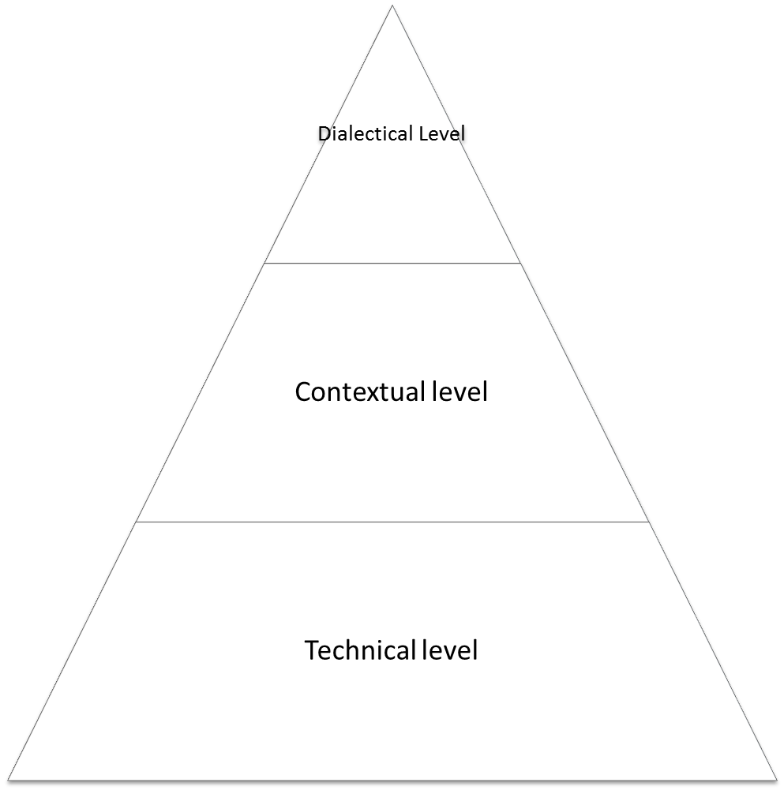

Handout 2
Criteria | Start Up" Language Routines | Do Now & Wrap-Up
Goals
Teacher’s role
Nature of student-teacher and student-student interaction
Role of the native language

Handout 3

Articles | Key points from the articles
ESL classroom routines

Involving students in classroom routines and processes

Routines for everyday language

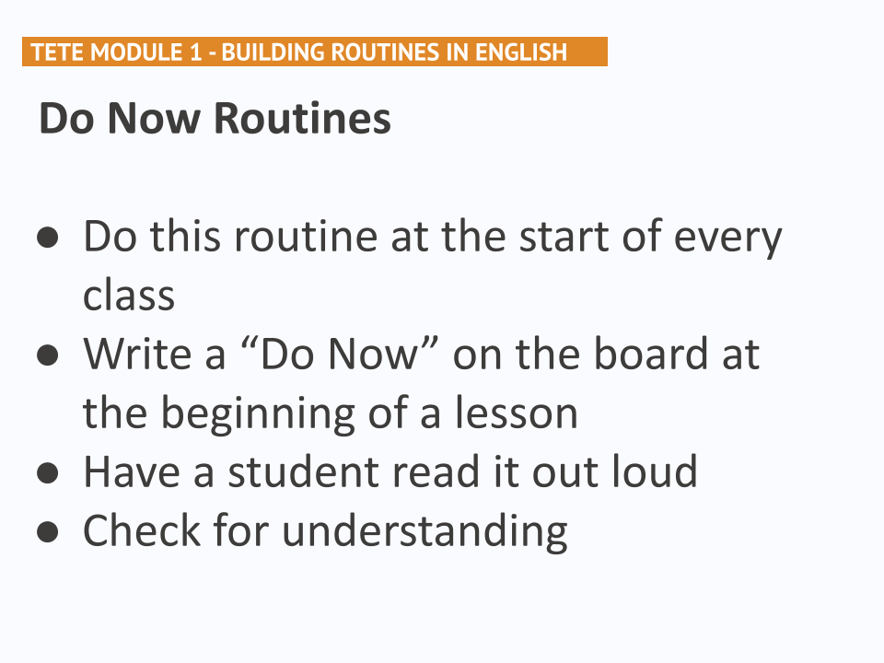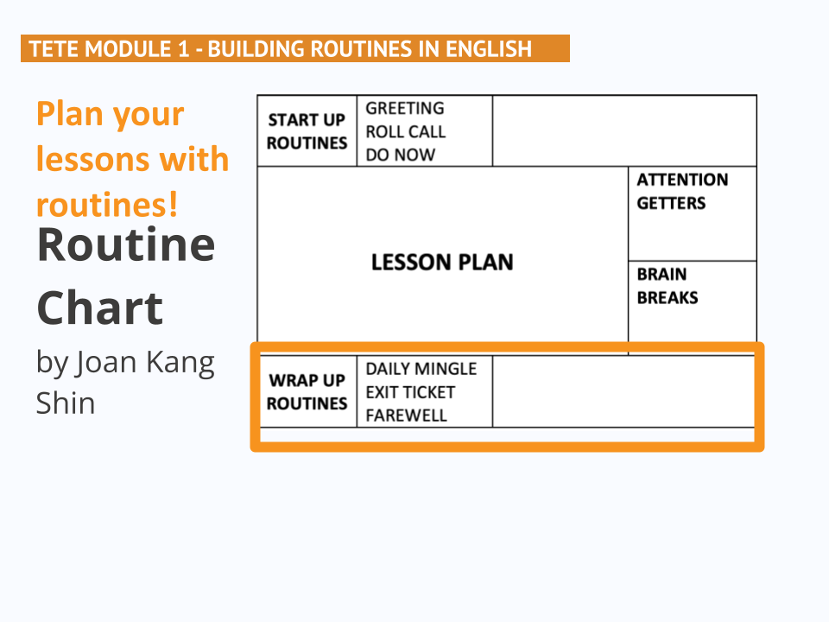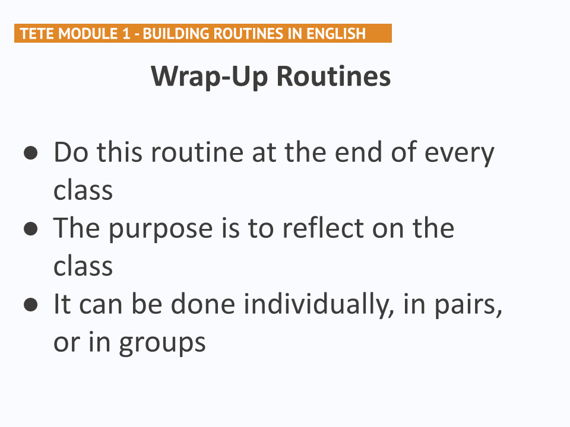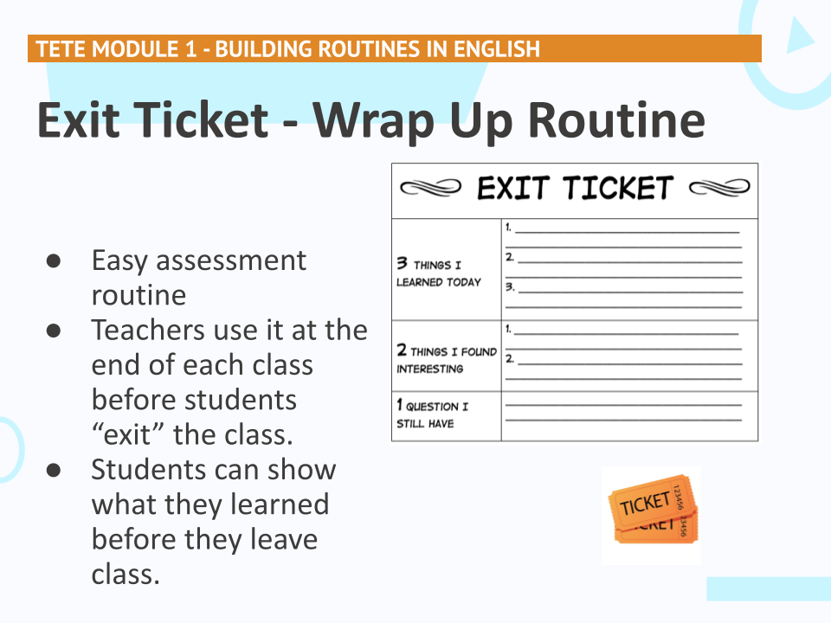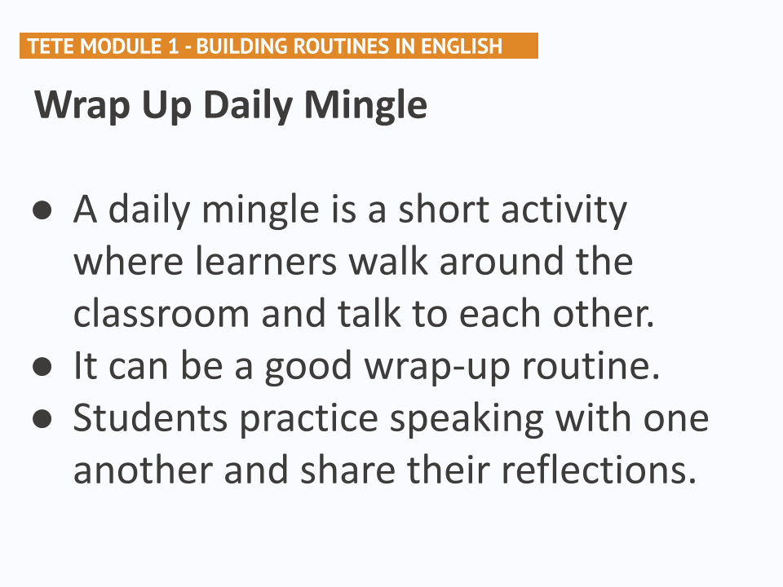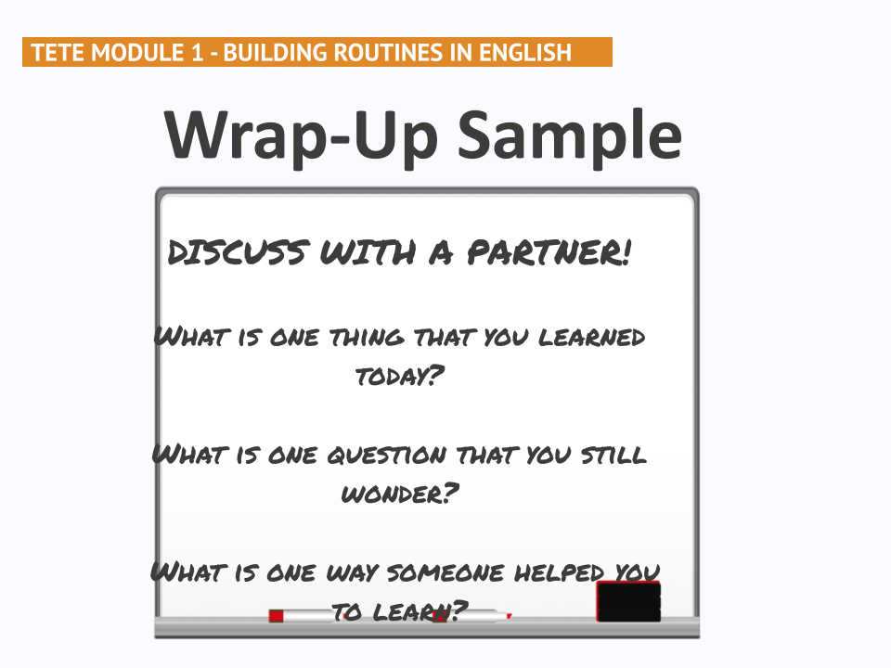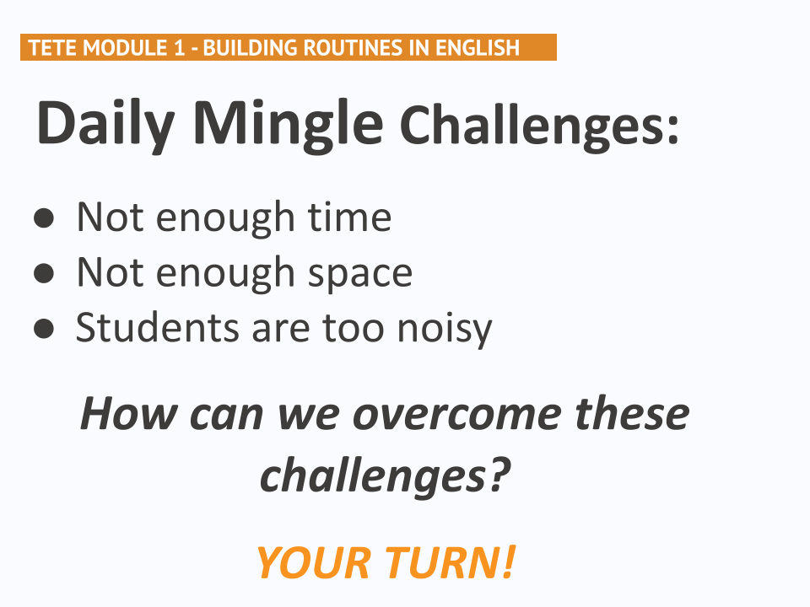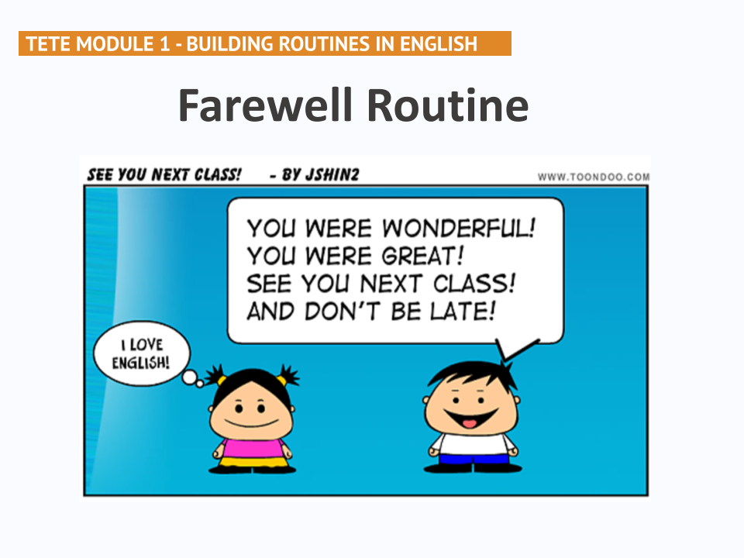
Handout 4
Write 1-2 paragraphs to reflect on Module 1 (300-500 words). You may use what you have created, shared, and applied in the previous tasks. You may also use the following as a template and fill in the blanks.

- Before this module about classroom routines, I used to (think/believe/use) __________________________________________________________________________.
- Now I (think/believe/plan to use) __________________________________________________________________________.
- This is important because __________________________________________________________________________.
- I (created/found) a classroom routine in Module 1 that I could use in my class to increase the use of English in the classroom. It is called (activity/routine title) _______________________________________________________________________ and I could use this during ________________________________________________________________________________________________________________________(when?/how?/why?).
- I like it because (apply Module 1 content) _____________________________________ _____________________________________________________________________.

- I might need to modify the (activity/routine) for my classroom because ______________ ____________________________________________________________________________________________________________________________________________.

Module 1 Participant Materials

Week 7
Module 2 Giving clear instructions
Welcome Message

Too often, students are unable to effectively participate in learning activities in the language classrooms, not because they do not understand the content but because teachers do not provide clear instructions. Through this module, you will explore the challenges, purposes, and ways of giving clear instruction in your English classrooms. You will learn how to give clear instructions using English and engage students to participate in communicative learning tasks.

Workshop Objectives

By the end of the module, participants will be able to:

describe the features of good teacher talk
use several modeling strategies
write and practice speaking effective teacher talk for your lessons
reflect on how to prepare a teacher talk and share a sample teacher talk using an activity

Lesson Plan

MODULE 2: Giving clear instructions |  |  | City/Region:  Venue: | Trainer:  The number of participants: | Date:  Time : 3 hours (180 minutes)
By the end of the module, participants will be able to:

- describe the features of good teacher talk
- use several modeling strategies
- write and practice speaking effective teacher talk for your lessons
- reflect on how to prepare a teacher talk and share a sample teacher talk using an activity

Language Point: Clear Instruction Language
Skills: Speaking, Listening, Reading, Writing
Material: Videos, handouts, flipcharts, PPT of the module

Stage/timing  Interaction | Activity type | Procedure
10 min | Warm-up  “Find someone who…” | - Tell the participants to use a “Find someone who …” table as they walk around the room trying to find a person who fits the question;  - Distribute the Handout 1 to every learner;  - Model the activity by inviting 2 participants; (Slide 2)  - It’s time to introduce the Module objectives to the class  (Slide 3)  Mini lecture: Too often, students are unable to effectively participate in learning activities in the language classrooms, not because they do not understand the content but because teachers do not provide clear instructions. Through this module, you will explore the challenges, purposes, and ways of giving clear instruction in your English classrooms. You will learn how to give clear instructions using English and engage students to participate in communicative learning tasks.
10 min | Preview  “Brainstorming” | Participants share their experience about some features of “good” teacher talk they use in the classroom.  Tell the participants to share their thoughts and write their versions on the board. After generating their answers show them the 4th slide:  - Consider the level of your learners  - Show careful modeling for your learners  - Be specific in expectations (purpose, group, time, etc.)  - Scaffold (supports and resources that help students achieve a task that would otherwise be too difficult) what is expected (break it down step-by-step)  - Remind your students of expectations-seek student understanding  - Give more “time” for using and learning and “less side-comments” (less is more)  Participants will compare their own versions with the given answers.  Tell the participants that throughout the lesson they will have a clear idea about those features.
20 min  Pair work | Experience – Conceptualize  Think-Pair-Share | - Ask the participants to show their elbow partners;  - Make them look at slide 5 and read the long instruction;  - Ask the learners to break the instruction into several steps based on their own experience with their partners.  Elicit random answers  The participants will explore ideas for giving clear directions by watching this video.  Video 1. Giving Clear Instructions for Forming Groups  Tell the participants that this video will help them deliver their instructions in simpler and more comprehensible ways to their students.  Link to YouTube: https://www.youtube.com/watch?v=1sNEHr5uczE  Participants check their answers by watching the video
40 min  Group work | Conceptualize  Four Learning Stations  Line-up | Station 1. Think Alouds can be used by EFL teachers to model classroom language and critical thinking skills.  Station 2. Different Think Aloud strategies and expressions can promote higher order of thinking and facilitate active target language use in EFL classrooms.  Station 3. Best practices for using Think Aloud.  Station 4. When giving classroom instructions, remember to “Just do it” and that “Less is more.”  - Divide the participants into four groups.  - Distribute Handout 2 to participants.  - Place four groups at four stations  - Groups will read the assigned paragraph of the article on Giving Effective Instructions: Using Think Aloud by Hyunsun Chung and Woomee Kim and discuss in their groups. They should answer the questions on their Handouts. (5 min)  - The groups move clockwise to change their stations. And stay at each station for 5 minutes and find answers to the questions asked in their handouts as a group. (15 min)  - Once the groups have found answers to all the questions asked, number the participants from 1 to 2. All ones and twos form 2 lines and face each other.  - Have the lines share their findings using their notes. (10 min)  Draw the participants’ attention to slide 6.  Discuss the question given on slide 7 in a whole group.
10 min | Break time

35 minutes  Group work | Conceptualize  Think Aloud strategy | - Go to slide 8 and show Video 2. Teacher Talk for Managing Activities  Tell the participants that this video is about more examples for effective teacher talk for managing activities.  Link to YouTube: https://youtu.be/F4RfqykJ6r8  - After they watch the video ask them to analyze the jig-saw activity they had in the previous stage.  - Was the instruction of the activity clear?  - Do you think that interacting with your partner has helped you understand the concept better?  Elicit random answers.  - Use the groups of four from the previous activity  - Distribute the article on Common Mistakes in Teacher Talk by Hyunsun Chung and Woomee Kim to groups (don’t show the second page of the article where is given the answers)  - Before they start reading it address them with the following questions:  Trainer: What are some things that learners struggle with in EFL classes?  Learners’ answers…  T: This article focuses on one of the challenges of learners: common mistakes in teacher talk. Before you dive into the article I want you to scan it. What are the title and subheadings of the article?  - Randomly choose a member from each group (or you can number the seats in advance and use the numbers to call a participant) to read out the first paragraph.  - Again question: -Why do you think that Communication in English is important in EFL class? Let them share their ideas  - Choose another participant to read out the second paragraph.  -What is meant by quality teacher talk?  -How do you consider good teacher talk in a language learning classroom?  - Have another participant read out the following part.  - Then distribute Handout 3 to each group and have them discuss the examples in their groups and identify the teacher’s mistake in the given Examples.  - Focus the learners’ attention on slides 9, 10, and 11 and let them share their answers.  - Ask other groups to give each other feedback.
15 min  Pair work | Think  Inner-Outer circle | Ask the participants to discuss the following questions by referring to the videos and articles they discussed. Read the questions and tell them to write the answer in their notebooks. (1 min)  When you see the participants are ready,  - Number participants from 1 to 2.  - Ask all ones to form an inner circle and all twos to form an outer circle where participants stand looking at each other face to face.  - Ask the participants to discuss the following questions by referring to the videos and articles they discussed. (Slide 12)  -What are some challenges you face when giving instructions in English in your class?  -How can you overcome these challenges?  - Make the inner circle rotate clockwise every 1 minute;  - As you mingle around the room and listen to their conversations, you can check for participants’ understanding of the session videos and articles.
35 min  Group work | Create and Apply  Role Play | Put the participants in small groups of five. Tell them that this module introduced some features of giving clear instructions. Based on what you’ve learned, choose one activity and create effective instruction in English for your students. Here you can use participants instead of your students. To design this role play, participants can consider the following:  - Groups will write a monologue of clear instructions that they say to their students.  - Groups will write a dialogue with a teacher and students, with the teacher giving clear instructions and students responding to the teacher.  - Participants may use expressions that are presented in this module and/or other expressions that they need to use in their teaching.  - Groups will create or adapt an existing activity with clear instruction they would like to use regularly in their current teaching context. They need to demonstrate the activity using clear instruction as a role play. (20 minutes)  - Groups will demonstrate the activity with the clear instruction that they have created. (3 minutes for each group)
10 min  Individual work | Wrap-up  3-2-1- Exit ticket | - Use slides 13 and 14 to anchor with Module 2 content  - Distribute Handout 4 (slide 15) to every learner  - Tell them to fill in the ticket (slide 16)  - After finishing they should give their tickets back to you so that you can read their feedbacks
5 min | Homework  Telegram group discussion | Write 1-2 paragraphs to reflect on Module 2 (300-500 words). You may use what you have created, shared, and applied in the previous tasks. You may also use the following as a template and fill in the blanks. (Handout 5)  Post your reflection in the Telegram group. Read your peers’ posts and comment on at least two posts by using the ‘reply’ function in the Telegram chat.  To finish the lesson use Slides 17 and 18

Handout 1

Find Someone Who……. | Name | More information
• used attention getters during the lesson
• used brain breaks during the lesson
• experienced mingling activities during the lesson
• did mingling activities where students enjoyed very much
• came across with some challenges while conducting mingling activities(not enough time, not enough space, students are too noisy)
• reflected on his/her learning in Module 1
• used exit ticket as assessment routine
• used praise and polish phrases during the lesson
• applied at least one new routine from the TETE course in his/her teaching context

Handout 2
 | Questions | Key points/answers from the article
Station 1 | 1. What is the purpose of using the Think Aloud strategy in EFL lessons?  2. Do learners need prior knowledge in Think Aloud?
Station 2 | 1. How can the Think Aloud strategy enhance students’ critical thinking?  2. What skills can the teacher develop in his/her learners using the strategy depicted in Figure 1?
Station 3 | 1. What are the best tips for using Think Aloud?  2. How do you imagine In Think Aloud teacher modeling?
Station 4 | - What do the mottos ‘Just do’ and ‘Less is more’ mean?  - Why lengthy explanations of activities are not recommended in language teaching?

Handout 3
Example 1.  T: What did you do yesterday?  S: It was a nice day, so, with my friends, I went to...uh...  T: To the park?  S: Uh...yes. | Example 2.  T: Carlos, please read sentence number one on the handout.  S: “The young man goes to bed...”  T: “...at midnight.” Monica, please read the next sentence.
Example 3.  T1: It was the best of times, it was the worst of times.  T2: It was the best of times, (1second pause), it was the worst of times. | Example 4.  T1: Now, I would like to write a question on the board, asking you what you did over the weekend. I am just going to grab the chalk, which is on my desk. There it is. I’ve got it. And...  S: Teacher, Is that the present perfect tense in that sentence?  T2: As a matter of fact, yes. Because my dog was sick yesterday and the day before, and he was still sick this morning. Remember, we use the present perfect, among other things, to show that an action started at some point in the past  and continues until now....

Handout 4 3-2-1 Exit ticket

Three words I’ve learned that capture effective teacher talk

Two Questions I have from Module Two

One new thing I will try out this week to give clear(er) instructions

Handout 5

Write 1-2 paragraphs to reflect on Module 2 (300-500 words). You may use what you have created, shared, and applied in the previous tasks. You may also use the following as a template and fill in the blanks.

Before this module about giving clear instructions, I used to (think/believe/use) ______________________________________________________________________________________________________________________________________________.

Now I (think/believe/plan to use) ______________________________________________________________________________________________________________________________________________.

This is important because ______________________________________________________________________________________________________________________________________________.

I (created/found) an example of effective instructions in Module 2 that I could use in my class to increase the use of English in the classroom. It is called (activity/routine title) _______________________________________________________________________ and I could use this during ________________________________________________________________________________________________________________________ (when?/how?/why?).

I like it because (apply Module 2 content) ______________________________________________________________________________________________________________________________________________.

I might need to modify the (activity/routine) for my classroom because ______________________________________________________________________________________________________________________________________________.

Week 6
Module 3 Effective Questions and Answer

Agenda
9:00 - 9:10
9:10 - 9:40
10:00 - 10:30
11:00 - 12:00
12:00 - 12:40
12:40- 1:00

Welcome Message

Workshop Objectives
Lesson Plan

MODULE 3: EFFECTIVE QUESTIONS AND ANSWER |  |  | City/Region:  Venue: | Trainer:  Number of participants: | Date:  Time : 3 hours (180 minutes)
By the end of the module, participants will be able to:
- understand how different types of questions are used in teacher talk
- form beginner friendly questions
- scaffold students’ response in more comfortable and effective ways
- practice basic question forms and answers with students

The quote of the session:
“The teacher who asks questions about the topic is more helpful than the teacher who explains the topic” James Clear
Language Point: Effective question and answer.
Skills: Speaking, Listening , Writing
Material: Videos, handouts, flipcharts

Stage/timing  Interaction | Activity type | Procedure
10 min  Pair work | Preview | Ask participants how they engage their students to participate in the lesson. How they make their students share their thoughts.  Participants share their experience about how they engage and make students communicate by using English.  Tell the participants to discuss the questions with elbow partners:  - Why is asking questions in English important?  - What is the role of asking questions in the classroom?  - What part of the activity do you usually ask questions - in the beginning, when transitioning, or at the end of a lesson? Why is it your favorite?  - How helpful is asking questions in the class?  Elicit random answers.
15 min  The whole class | Apply | - Show the picture to participants and ask some questions.  - “Before you watch, what do you think this dialogue will be about?”  - “Before you watch, brainstorm what you think about this video.”  - “Look at this picture. What do you think about when you see this picture?”  Appendix 1  - Let trainees brainstorm and predict the video.  - Play the video Small Talk - YouTube and let participants watch half of the video. Pause the video in its half and by asking questions ask CCQ (Comprehension Checking Questions) check participants' ability of understanding the main idea of the video.  - “Is the old man the young boy’s grandad?”  - “Are they talking about the weather or love”?  - “Is the man single or married”? Why do you think so?  - Play the rest of the video.  - Discuss with participants about their prediction. Whether they were right or not with their prediction.
10 min  Individual work | Reflection | - Ask the participants to reflect on the listening and speaking integrated activity they have experienced by answering the following questions:  - Did you like this activity? Why?  - How did you feel during the activity?  - What have you learned from the activity?  - What is the role of asking questions in this activity?  - State that this is an example of engaging students to the class by asking questions in order to make them speak.  - Say that you used two techniques of asking questions like prediction and checking the understanding of the main idea.  - They also may use more questioning techniques like asking for specific information and making inferences and asking opinion. As you strive to establish asking effective questions and providing good answers toward a communicative language classroom environment, your students will increase in learning and use of the target language.  - Say, “this module will help you explore different techniques of effective questions and answers you can apply to your teaching context while using English. You will learn the purpose and examples of effective questions and answers to enhance the use of English in your communicative classroom.”
25 minutes  Group work | Conceptualize  Video discussion | The participants will explore the ideas for effective questions and answers in English by watching two videos.  Video 1. “Asking Questions during Listening Tasks”  Tell the participants that this video will introduce some techniques of asking effective questions in English in pre-while-post activities.  Link to YouTube: TETE - Asking Questions During Listening Tasks - YouTube  Video 2. “Practicing Wh-Questions using Information Gap Activities”  Tell the participants that this video will show you an example of how to lead your students to form and use basic wh-questions in classroom activities.  Link to YouTube: TETE - Practicing Wh Questions Using Information Gap Activities - YouTube
30 min  Group work | Apply | Tell trainees they will be designing open-ended Wh-questions and changing some of them to Yes/No response questions.  - Review Wh-questions and Yes/No response questions with trainees.  - Provide a list of Wh - Questions and stick on the board.  - Divide the class into two groups.  - Ask groups to read the passage. Appendix 2  - Ask groups to make Wh -questions based on topic.  - Have groups exchange developed questions and answer the questions of the partner group.  - Tell trainees to change some open - ended response questions to Yes/No response questions on the table in Handout 1 . (sample is in Appendix 3)  - Provide constructive feedback.
40 min  Group work | Conceptualize  Jigsaw Reading | Home group - Guest Group – Home group.  Group 1. CREATING OR ADAPTING BEGINNER-FRIENDLY QUESTIONS  Group 2. INCREASING WAIT TIME  Group 3. NON-TRADITIONAL STUDENT RESPONSES  - Divide the participants into three groups. Tell them that this is their Home group. They will read the assigned article Questions and Responses and discuss it in their groups. They should take notes on the table. (15 minutes)  - Number the participants from 1 to … . tell them to show their number with fingers and keep their fingers up to find their group. All the participants who are number one will form one group, all the twos will form group two, so on.  - When group members meet in the guest group (new group) they share the information they discussed in their host groups. Tell the participants to take notes on the table. (10 minutes) (Handout 2)  - Ask the participants to go back to their home groups with their notes and share their findings. (10 min)  - Ask the groups to share what they have learned about routine activities. Elicit random responses. (5min)
15 min  Pair work | Reflect/ Experience  Mingle around activity | Ask the participants to discuss the following questions by referring to the videos and articles they discussed. Read the questions and tell them to write the answer in their notebooks. (1 minute)  - Which of the suggested effective questions and answers do you think can be adaptable to your teaching context? Why and why not?  - How do you plan to apply them into your classroom?  When you see the participants are ready, tell them:  - “Now, walk around the room to find a partner to share what you wrote. Please, talk at least to two peers”  - “As you listen, write down what your partner said in your notebook.”  As you mingle around the room and listen to their conversations, you can check for participants’ understanding of the session videos and articles.
5 min  The whole class | Discussion | If you have some time you may ask participants to reflect on the quote of the session:  “The teacher who asks questions about the topic is more helpful than the teacher who explains the topic”  James Clear  - How do you understand this quote?  - Do you agree? Why?
10 min  Pair or group work | Wrap-up | For the wrap up at the end of the session, you can go to objectives and ask questions:  - Do you understand how different types of questions are used in teacher talk  - Can you form beginner friendly questions? Any examples please?  - Can you scaffold students’ responses in more comfortable and effective ways? How?  - Have you practiced basic question forms and answers during the sessions? How?  Put participants into groups of 4. Each participant writes a different question on the top of the paper. They will be given 1 minute and 30 seconds to write their answer.  They then must fold their paper so that the next person can’t see
5 min | Homework  Telegram group discussion | - Choose a part (reading or listening) task  - Create a set of questions that fits for the learning goal of the part you’ve selected.  - Simplify questions for low level students.  - Refer to today's lesson to create questions.  Post your reflection in the Telegram group. Read your peers’ posts and comment at least to two posts by using the ‘reply’ function in the Telegram chat.

Appendix 1
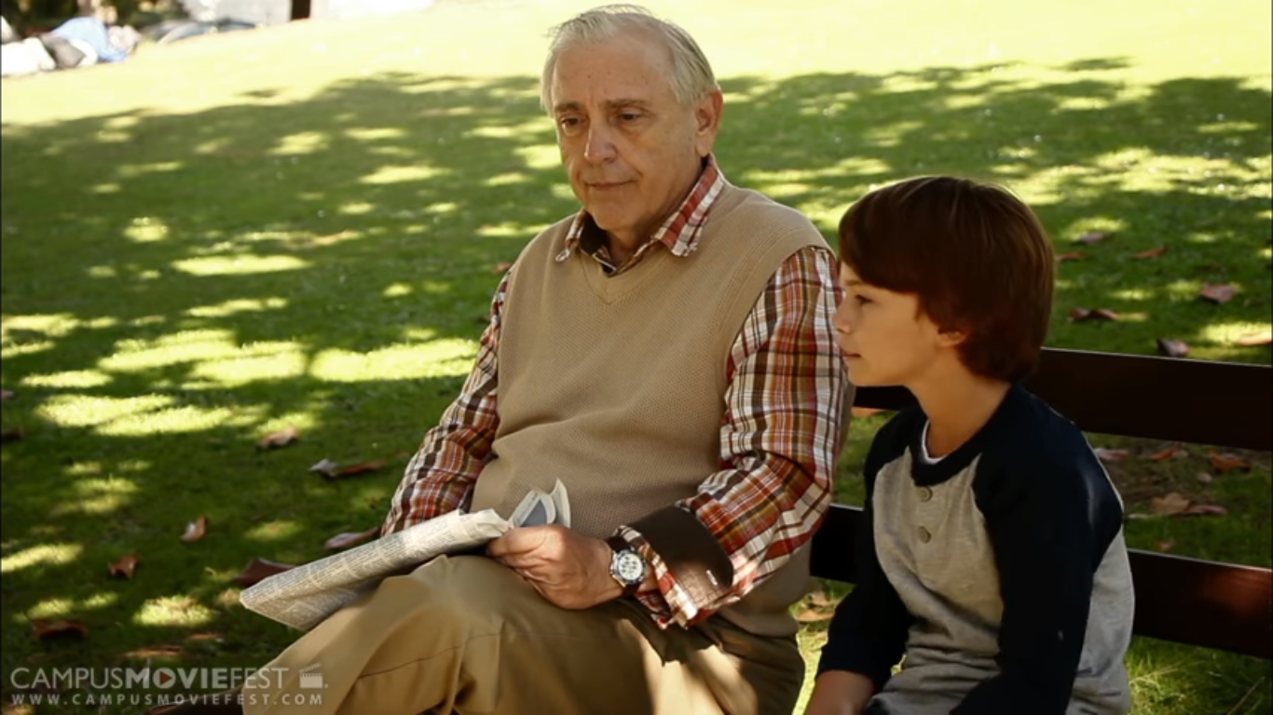

Appendix 2
Source : Teens 8 (page 20)

Appendix 3.

Open-Ended Response | Yes/No Response
What characteristics tell you that an animal is a mammal? | Is this animal (in the picture) a mammal?
How do you know a shape is a rectangle? | Does a rectangle have four sides?
What is the weather like today? | Is the weather sunny today?
What foods do you like to eat? | Do you like to eat eggs? Rice? Fish?

Handout 1

Open-Ended Response | Yes/No Response

Handout 2

Articles | Key points from the articles
CREATING OR ADAPTING BEGINNER-FRIENDLY QUESTIONS

INCREASING WAIT TIME

NON-TRADITIONAL STUDENT RESPONSES

Welcome Message
Feedback is one of the most important teacher-student interactions in any learning environment. This is especially true in effective language classrooms. By using appropriate language and feedback approaches, you will be able to create safer and more productive English learning environment for your learners. This module will help you explore goals and different feedback strategies in English to foster communicative language development in your learners.

Workshop Objectives

By the end of the module, you will be able to:
- understand what to do after tasks or lessons to check comprehension and increase students’ learning
- use appropriate teacher talk for feedback depending on different learning goals
- correct students' errors with different feedback strategies.

Lesson Plan
Workshop Training Plan Template

Workshop Title: Module 4: Checking Comprehension and providing feedback

Workshop Description: Feedback is one of the most important teacher-student interaction in any learning environment. This is especially true in effective language classrooms. By using appropriate language and feedback approaches, you will be able to create safer and more productive English learning environment for your learners. This module will help you explore goals and different feedback strategies in English to foster communicative language development in your learners.

Nine Events | Description of Instructional Event | PowerPoint Slides or Handouts
- Gain attention  (20 -25 minutes) | Gain their attention with a quote: "We expert teachers know that motivation and emotional impact are what matter." - Donald Norman  - Presenting topic-related words, less common collocations and idiomatic expressions through brainstorming and slides focusing on their use in context  - Elicit participant responses about what the quote means. (to ensure that they fully comprehend what they need to do to achieve in their classrooms)  - Divide participants into 4 groups and present a challenge  (Imagine you have a situation that you feel everyone in a group has a difficulty to understand the new theme what will you do? )
- Inform learners of objectives  (20 minutes) | By the end of the workshop, teachers will be able to:  - correct students' errors with different feedback strategies.  - understand what to do after tasks or lessons to check comprehension and increase students’ learning  - use appropriate teacher talk for feedback depending on different learning goals | PPT slide
1. Stimulate recall of prior learning  (25 minutes) | - Stimulate participants beliefs in about using corrective feedback to improve students` confidence to interact and speak in English.  Ask “How do you give feedback to your students? Do you use different feedback strategies for different needs? What are some of the goals that you have when you give feedback or correct the students’ language errors?” Elicit answers from participants.  - Mini-lecture on benefits of whole class formative feedback  - Feedback strategies beyond error correction.  - Anxiety free corrective-feedback. | Question:  How do you give feedback to your students?  Do you use different feedback strategies for different needs? What are some of the goals that you have when you give feedback or correct the students’ language errors?
- Present the content  (20 – 25 minutes) | Demonstrate the videos from TETE:  Video 1. Whole class formative feedback. After watching Video 1 check the participants understanding through Thumbs up/Thumbs down activity  Video 2. Feedback strategies beyond error correction  After watching Video 2 check the participants understanding through Respond Cards activity  Video 3. Anxiety free corrective-feedback | Videos  1.  https://sites.google.com/view/mason-tete/module-4-checking-comprehension-and-providing-feedback?authuser=0#h.vr71igbf5es7  or  https://www.youtube.com/watch?v=sfJmK2_tOEs  2. https://sites.google.com/view/mason-tete/module-4-checking-comprehension-and-providing-feedback?authuser=0#h.vr71igbf5es7  or  https://www.youtube.com/watch?v=QXs-QVGqKBA  https://sites.google.com/view/mason-tete/module-4-checking-comprehension-and-providing-feedback?authuser=0#h.vgqaj0amj4px  or  https://www.youtube.com/watch?v=YoK6lIKnE4Y
5. Guide learning | Reading the Article 2: Giving Effective Instructions: Using Think Aloud by Hyunsun Chung and Woomee Kim  Gallery walk (A “Gallery Walk” is an activity that allows participants/students to discuss and display their final work around a room much like artists would display their artistic pieces in an “exhibit.” It is a way that participants/students can share their group work projects or individual literary responses to a text in a non-threatening way with the assurance of getting some feedback from their learning community) | https://www.readingrockets.org/article/using-think-alouds-improve-Reading-comprehension
6. Elicit performance (practice) | Based on your preference, choose one of the following tasks:  1. Are there any feedback strategies presented in this module which you have learned for the first time? If so, which ones? Create a list and describe how you would use these strategies with your learners.  OR  2. Are there any feedback strategies that you currently use, but are not presented in this module? What are they? Create a list and describe how you would use these strategies with your learners? Do these feedback strategies focus on correcting form or improving communicative skills?  Consider your teaching context and learner characteristics when thinking about this topic. Also think about if these feedback strategies focus on correcting form or improving communicative skills.
7. Provide feedback | Participants work in small groups to demonstrate a role play of teacher and students and they show how to apply new strategies for giving feedback. | P-Praise  Q-Question  P-Polish
8. Assess performance | - Participants write 1-2 paragraphs to reflect on Module 4.  - Collect the Exit Tickets to assess participants’ understanding of workshop content.
9. Enhance retention and transfer | Before leaving the workshop ask participants which part of the workshop they liked and how they will change it or implement without change in their training sessions with mentees.

Week 7
Module 5 Increasing classroom interaction

Agenda
9:00 - 9:05 | Warm-up
9:05 - 9:15 | Preview
9:15 - 09:45 | Mingling Activity
09:45 - 09:55 | Reflection
09:55 - 10:25 | Conceptualizing/ Video discussion
10:25- 10:40 | Break
10:40- 11:10 | Conceptualizing/ Powerpoint
11:10-11:35 | Reading/Standing Triangles
11:35- 12:15 | Apply
12:15- 12:25 | Wrap up quiz
12:25- 12:30 | Homework

Welcome Message
"A mouse saved her young from a ferocious cat by barking 'bow-wow.'
After the cat ran away, the mouse said to her offspring 'See, children, it pays to know a second language.'" - Efstathiadis

Hello English teachers! Are you ready to power up your English class? We know that to learn the language, we need to use language. Our classrooms can become an important and safe space for our students to practice English through interactions.Today, we will explore some tips for increasing student-to student interaction in our classrooms. We will practice some activities that promote classroom interaction. We will read the article and share our experience.

` Workshop Objectives
I can explain the importance of learner interaction in acquiring a second language

I can plan the interactional group task
I can apply some of the new interactive activities in the classroom
I can share some of the effective activities that increase student-to-student interaction in our classrooms

Lesson Plan
​​
MODULE 5: INCREASING CLASSROOM INTERACTION |  |  | Date:  Time : 3 hours 30 minutes (210 minutes)
By the end of the module, participants will be able to:
- describe the importance of student-to-student interaction in a language classroom
- examine and use a variety of effective activities that promote meaningful interaction in a
classroom
- share different communicative activities that are effective for English learners

Language Point: Classroom language
Skills: Speaking, Listening , Writing, Reading
Material: Videos, handouts, flipcharts, graphic organizers
Stage/timing  Interaction | Activity type | Procedure
5 min  Welcome  Routines  9:00-9:05 | Warm-up | Welcome Message, Agenda, Quote, Pairs,  Groups and Elbow partners & wake up movement  Sentence scramble  - Divide the students into small groups or pairs  - Come up with a few sentences before class, print them out and cut them into pieces OR write the sentence’s words on the whiteboard in a random order.  - Give each group a different set of scrambled sentences.  - Ask the groups/pairs to unscramble the words and read the sentences aloud correctly  - You can use motivating mottos or the target language of the day.(Handout 1)  e.g. The human brain is designed to think while moving. (Dr.James Levine, Why your chair is killing you and what to do about it, 2014)  Movement is an essential factor in intellectual growth. (Maria Montessori, The secret of Childhood,1996)  - Discuss the mottos and benefits of moving in the classroom with the whole class.  Answers will be varying. Accept all the answers.
10 min  Pair work  9:05-9:15 | Preview | Introduction to the workshop.  - Give brief information about the workshop objectives.  - Ask participants to answer the question “Why is classroom interaction important for language learning?’  Trainees individually write the reasons why classroom interaction is important for language learning . They write down as many ideas as they can on a piece of paper.  .  - Tell the participants to share their ideas with elbow partners.  - Elicit random reasons and opinions.  Alternatively you can:  - Divide the class into two groups.  - Choose a volunteer to come forward from each group. They are both given a total of 2 minutes to ask the teachers from their group as many answers to the question as possible. The team with the most answers wins.
30 min  Individual work  9:15-09:45 | Experience –  Mingling Activity | - Tell the participants to act the role of school students to practice one Mingle activity.  - Begin by explaining to the participants that Getting to Know You activities are a great way to begin increasing classroom interaction. Students get to share information about themselves, as well as anything unique or special about them.  - Have a set of questions ready for participants to ask each other. And the last one can be an open-ended, participant’s choice question. (Handout 1. Graphic organizer)  - First, read through each question with the whole class. Then have your participants write their own question they want to ask their classmates. For example, “Who is your favorite music group and why?”  - Explain the two most important rules, “ You must speak English and you must try to speak to as many different people as possible.”  - When everyone is ready to mingle, it’s time to stand up  and go greet someone hello. Participants will introduce their names and then begin interacting. Have them mingle around the room, speaking to at least three people in the classroom in 5 minutes.  - Once they finish interviewing one person, they can say goodbye and move onto the next person.  - Ask some ICQs to check their comprehension.  - Provide guidance or corrections as needed.  Or  - You can have all the teachers' names on little sheets of paper. Call random people and ask them to share what they learned about a classmate.
10 min  Individual work  09:45-09:55 | Reflection | - Ask the participants to reflect on the sample activity they have experienced by answering the following questions:  - Did you like this activity? Why?  - Do you feel that there will be plenty of real-life communication going on in the classroom?  - What kind of follow up communicative activity can be used to extend further?  - What topics can you use a mingle for in your class?  - State that this is an example of activity that helps to increase student-to-student interaction in the classroom. Say that English language students need to speak out! English teachers everywhere struggle to increase the quantity and the quality of English spoken by students in their classrooms. In global contexts where English is not commonly spoken in everyday life, students may only have our classroom to practice speaking. Say that this module will help participants explore different activities to promote meaningful interaction in a classroom. They will learn new strategies to create an interactive and communicative classroom that includes promoting more student-to-student interaction.
30 minutes  Group work  09:55-10:25 | Conceptualize  Video Discussion | - The participants will explore the ideas for increasing classroom interaction by watching two videos.  Video 1. Find Someone Who Bingo  - Tell the participants that this video will introduce Icebreaker activity that can be used in English language classes to get students in the mood to talk and interact more.  Link to YouTube: https://youtu.be/oHoVJhnRKCc  Video 2. Guiding the Artist  - Tell the participants that this video presents steps to promote students' communicative interaction in their classroom through Guiding the Artist activity.  Link to YouTube: https://youtu.be/bdIK_k83QPg  - After they watch the video, ask them to analyze the activities.  - Ask the participants to think about the questions, exchange their opinions with their elbow partners and share with the whole class what they discussed.  Think, Pair, Share.  - What was the purpose of the activities?  - Which of the suggested activities do you think can be adaptable to your teaching context? Why and why not?  - How do you plan to apply them into your lessons?  - Do you think your pupils will enjoy the activity?
15 min

Break
10:25-10:40
30 min  Group work  10:40-11:10 | Conceptualize | - Talk about the types of activities that get the students out of their desks and promote interaction in the classroom such as Line up, Concentric Circles, , Info-Gap, Anchor Charts, Guessing Game, Jigsaw, etc. (Powerpoint presentation)
25 min  11:10-11:35 | Experience  Standing Triangles | Incorporating Opportunities for Interaction and Sharing  https://americanenglish.state.gov/files/ae/resource_files/sept_week_3_interaction_and_sharing_final.pdf  - Tell that this article introduces simple ways to incorporate interaction to their lessons. The strategies described can keep learners moving and talking.  - Divide the participants into three home groups and ask them to read the assigned part of the article for two minutes:  Group 1. Turn and Talk  Group 2. Think, Pair, Share  Group 3. Stand up/Sit down (or Thumbs up/Thumbs down)  - Divide the students into groups of three including one member from each home group. They will read for 10 minutes and all must write down the same points.  - Assign roles to teachers in their expert groups such as question asker, write checker (the person who checks that all team members wrote down their answers) and time keep.  - Ask participants to stand in a triangle and share the information that they have read with each other.
40 min  Group work  11:35-12:15 | Apply | - Divide the participants into groups of four.  - Tell them that this module introduced several different classroom activities that increase student-to-student interaction.  - Ask them to create a new or adapt an existing activity based on what they learned, they would like to use regularly in their current teaching context.  - Tell the participants to practice their activity with others in 5-10 minutes.  After practicing, ask participants to answer the following questions about their interaction activity (or strategy):  -What stage of the lesson can you use this activity (or strategy)and why?  -How has this activity (or strategy) promoted meaningful communication?  -What visual aids can you use, if any, to make your activity (or strategy) more interesting and meaningful?
10 min  Whole class  12:15-12:25 | Wrap-up | For the wrap up at the end of the session:  Digital Wrap-up: Participants will answer the Blizz Questions or Kahoot quiz  Link to the Quiz: https://wordwall.net/resource/5056615
5 min  12:25-12:30  Homework | Telegram group discussion | - Create an activity (or strategy) that will generate communicative interactions among students. Use the template below when creating your activity.  Activity Name:  Activity Description:  - This activity is effective because…  - Here are some steps to help you use this activity in your classroom:  Step 1:  Step 2:  Step 3:  Share the activity (or strategy) you created in the group chat. Be sure you post an activity that you have not seen already in the group chat. Please post a brief message and attach a Word document, PDF, or PPT slides with your activity. You may use the following message as a template.  Example  Hello, Colleagues! The activity I want to share to increase classroom interaction is called _____________________________________________________________ (activity title). This activity is effective because_________________________________________________________________________________________________________________________________. See the three simple steps in the attached file for an example on how I use this activity in my classroom to increase interaction. (Be sure to attach your activity file.)  - Write 1-2 paragraphs to reflect on Module 5 (300-500 words). You may use what you have created, shared, and applied in the previous tasks.

Handout 1.
- The human brain is designed to think while moving. (
(Dr.James Levine, Why your chair is killing you and what to do about it, 2014)

- Movement is an essential factor in intellectual growth. (Maria Montessori, The secret of Childhood,1996)

Handout 2.

Questions: | Name of classmate | Name of classmate | Name of classmate
1.Where do you live?
2.What are your hobbies?
3.What is your favorite food?
4. What is your favorite word in English?
5.Write a question you want to write:__________ _____________________

Handout 3.
https://www.google.com/url?q=https%3A%2F%2Famericanenglish.state.gov%2Ffiles%2Fae%2Fresource_files%2Fsept_week_3_interaction_and_sharing_final.pdf&sa=D&sntz=1&usg=AFQjCNGdIg9e4p8W_uQDIVz7ZC0P-rRbDw

Handout 4.
Wrap-up Quiz: https://wordwall.net/resource/5056615

Powerpoint Presentation: https://docs.google.com/presentation/d/1Uq8xgghuScoxuo9KwgyMrDSkpLEkZ5T862cOcDFvS5s/edit?usp=sharing

Week 8

Module 6 PTRA - Plan, Teach, Reflect, Adjust
Welcome Message

Workshop Objectives

Lesson Plan

Training Planner
Session Title | Module 6. PTRA Plan, Teach, Reflect, Adjust
Delivery Date | Approximately on 25.03.2021
Learner Numbers | 22
Session Duration | 9:00-12:30
Location | Sergeli District , School # 6
Training Session Objectives | By the end of the module, you will be able to:  - plan, teach, reflect, and adjust lesson plans to promote effective communicative language practice in their classrooms  - develop an effective lesson plan for English learners that teaches language through meaningful context and promotes communicative interaction using engaging activities
Written by Trainers/ CTs | Dildora Kasimova , Nigora Karimova, Hurshida Eshimova, Klara Nizomutdinova, Umida Sobirova

Time | Details | Equipment
9:00-9:15  Warm-up | Step1. Introduce the topic of the session using the Agenda and Welcome Message  Step 2:  Write the objective for the find your partner mingle activity on the board:  Teachers will be able to identify objectives for different topics by speaking and listening.  Step 3:  Warm up activity, “Find Your Matching Pair Mingle”  Trainees will be divided into two groups. One group will get topic names, the second group will get a set of objectives to each topic, but both topics of the lessons and objectives will be mixed up.  Listeners should mingle about the room and find their partner with the matching topic or an objective.  The rule is they must say what is on their paper, they cannot show it to anyone. | Handout №1
9:15-9:30 | Brainstorming Question  Trainer asks this questions to participants, “What do you think this chart is used for and when?”  Introduction of the KWL chart. Teachers will get information about the KWL chart. KWL – is a graphic organizer that helps students organize the information they had learned before, after, while and their desire to know deeper about the topic they are learning.  After the introduction teachers will be asked to practice with Handout № 3 applying the knowledge about lesson planning and its objectives.  Trainer can say after hearing their ideas, this chart can be used in different ways. The key way to use it repeatedly during a lesson.  Teacher tells the participants, please write what you know about objectives and write it in the know column. | Handout № 3, Board, pencils and pens.
9:30-10:00  Reflection Discussion | Discuss answers and introduce the writing of good objectives.  - What have you done just now, was it difficult for you to find your matching partner, why?  - What helped you to find your matching partner?  - What key words did you pay attention to when you were looking for your matching partner?  - To what extent do you agree that objectives of the topic were written in accordance with the topic?  - What would you change and why?  After the discussion, there will be a mini-lecture on lesson objectives and examples of effective and ineffective objectives shared by a trainer. | Pencils, pens and Notebooks, a board
10:00 - 10:20  Conceptualize  Video Discussion | Trainees will be asked to watch Video1 (taken from the TETE course) which is devoted to writing good and measurable objectives. While watching learners should make some notes to use them in the further discussion  Video 1: Writing Good Objectives  - This video will emphasize the importance of writing good objectives and suggest how to write good objectives.  Link to YouTube: https://youtu.be/IHo7eqElKg0 | Projector, Monitor, Flash card or Internet.
10:20- 10:30 | When learners have watched Video 1, the following questions are suggested to ask and discuss. It will help them to refresh their ideas and prepare them for the further actions related to choosing activities to achieve objectives of the topic.  When you are planning your lesson do you answer the following question:  Do you think that your objectives are specific, Measurable, Attainable, Relative and Timely?  Practice: Participants will be required to work in pairs and go back to the warm up activity Handout 1. They should sort them out into two categories: well written objectives and less well with reliable justification. | Pencils, Note- Books, Pens  Handout№ 2  Vocabulary related to writing objectives: Knowledge, Comprehension, Application, Analysis Synthesis, Evaluation
10:30-10:40 | Break time
10:40-11:00  Conceptualize  Video Discussion | Video 2: Sequencing Activities.  Trainees will be asked to watch Video 2 (taken from TETE course) which is devoted to creating meaningful activities, which trigger a good assessment, evaluation and complexity of activities chosen related to the topic. While watching learners should make some notes to use them in the further activity completion.  - This video will demonstrate how to sequence activities in a lesson to promote a meaningful language learning environment throughout instruction.  Link to YouTube: https://youtu.be/B7BXBQma8h8 | Projector, Monitor, flash card or Internet.
11:00-11:30  Production and Application | The auditory will be asked to create a mini lesson plan relying on lesson objectives, procedure, timing, aids and interaction.  - Divide your participants into small groups  - Explain to them that they are going to create a mini lesson plan in small groups.  - They must choose an age, topic, level, and write a possible  Include one lesson plan and write an objective using Bloom’s Taxonomy verbs.  Ask teachers to write the objectives for one sample lesson plan.  Think about how different three types of students can | Markers and post-papers, stickers.
11:30-12:00  Presentation  Application | Participants will be required to present their lesson plans frontally to other groups. Each group has only 5 minutes to present their mini lesson with a brief presentation.  Other groups are asked to make notes on good points and lack of mini lesson plans. This will prepare the auditory for the reflection part of the session.
11:40-12:15  Conceptualize  Video Discussion | Teachers will be familiarized with Reflective teaching. They will explain that reflection should be a vital part of our teaching practice. It not only has a role throughout our lesson planning and teaching, but also has a specific role after the planning and teaching stages, and before the adjusting stage.  Video 3: Activating Your Reflective Teaching  This video explains the role that reflection plays in teachers' daily instruction. It also provides key questions you can ask to develop your reflective practice. | Projector, Monitor, flash card or Internet.
12:15-12:25  Article Reading  Using a summary of a summary | Article 1: PTRA: Plan, Teach, Reflect, Adjust by Woomee Kim  - Design, delivery, and reflection are fundamental to effective lesson planning. In  this article, reflective teaching strategies are emphasized with a set of guiding questions that you can ask before, during, and after you teach a communicative lesson.  - Source: Kim, W. (2021). PTRA: Plan, teach, reflect, and adjust. Teaching English through English: English Speaking Nation for Uzbekistan Program.  https://drive.google.com/file/d/1utrDM7Ma6FfVNzeC1qWynWDyToI4zmxd/view?  usp=sharing  Wrap up the article comprehension by supporting TRUE / FALSE activity on Paperboards and using Markers.  The auditory will be required to make TRUE/ FALSE sentences in groups with the relation of the article read. Just after they complete their TRUE/ FALSE sentences, each group will be asked to read their sentences while others respond via paperboards writing TRUE/ FALSE.  Remember: To provide a summary of the session, Check list is suggested to be handed and done in pairs. | Handout №5  Article
Homework  Telegram discussion | Take on lessons from your curriculum and write 1 original objective for one class lesson using Blooms.  For one lesson they can write 2 or 3 objectives  Designing a lesson plan with the accordance of the learnt material and sharing it in a telegram group.

Alternative variant of Module 6

MODULE 6:  PTRA Plan, Teach, Reflect, Adjust |  |  | Date:  Time : 2 hours (120 minutes)
By the end of the module, participants will be able to:
- plan, teach, reflect, and adjust lesson plans to promote effective communicative language practice in their classrooms
- develop an effective lesson plan for English learners that teaches language through meaningful context and promotes communicative interaction using engaging activities.
Language Point:
Skills: Speaking, Listening , Writing
Material: Videos, handouts, flipcharts
Stage/timing  Interaction | Activity type | Procedure
10 min  Welcome  Routines | Warm-up | Step 1:  Write the objective for the find your partner mingle activity on the board:  Teachers will be able to identify objectives for different topics by speaking and listening.  Step 2:  Warm up activity, “Find Your Matching Pair Mingle”  Trainees will be divided into two groups. One group will get topic names, the second group will get a set of objectives to each topic, but both topics of the lessons and objectives will be mixed up.  Listeners should mingle about the room and find their partner with the matching topic or an objective.  The rule is they must say what is on their paper, they cannot show it to anyone.
5 min  Pair work | Preview | .  Introduce the topic of the session using the Agenda and Welcome Message  Brainstorming Question  Trainer asks this questions to participants, “What do you think this chart is used for and when?”  Introduction of the KWL chart. Teachers will get information about the KWL chart. KWL – is a graphic organizer that helps students organize the information they had learned before, after, while and their desire to know deeper about the topic they are learning.  After the introduction teachers will be asked to practice with Handout № 3 applying the knowledge about lesson planning and objectives of the lesson..
10 min  Pair work | Experience  Discussion | Discuss answers and introduce the writing of good objectives.  What have you done just now, was it difficult for you to find your matching partner, why?  What helped you to find your matching partner?  What key words did you pay attention to when you were looking for your matching partner?  To what extent do you agree that objectives of the topic were written in accordance with the topic?  What would you change and why?  After the discussion, there will be a mini-lecture on lesson objectives and examples of effective and ineffective objectives shared by a trainer.
10 min  Group work work | Conceptualize | Trainees will be asked to watch Video1 (taken from the TETE course) which is devoted to writing good and measurable objectives. While watching learners should make some notes to use them in the further discussion  Video 1: Writing Good Objectives  This video will emphasize the importance of writing good objectives and suggest how to write good objectives.  Link to YouTube: https://youtu.be/IHo7eqElKg0
15 minutes  Pair work | Reflection | When learners have watched Video 1, the following questions are suggested to ask and discuss. It will help them to refresh their ideas and prepare them for the further actions related to choosing activities to achieve objectives of the topic.  When you are planning your lesson do you answer the following question:  Do you think that your objectives are specific, Measurable, Attainable, Relative and Timely?  Practice: Participants will be required to work in pairs and go back to the warm up activity Handout 1. They should sort them out into two categories: well written objectives and less well with reliable justification.
10 min  Group work | Conceptualize | Video 2: Sequencing Activities.  Trainees will be asked to watch Video 2 (taken from TETE course) which is devoted to creating meaningful activities, which trigger a good assessment, evaluation and complexity of activities chosen related to the topic. While watching learners should make some notes to use them in the further activity completion.  This video will demonstrate how to sequence activities in a lesson to promote a meaningful language learning environment throughout instruction.  Link to YouTube: https://youtu.be/B7BXBQma8h8
20 min  Pair work | Apply | - The auditory will be asked to create a mini lesson plan relying on lesson objectives, procedure, timing, aids and interaction.  - Divide your participants into small groups  - Explain to them that they are going to create a mini lesson plan in small groups.  - They must choose an age, topic, level, and write a possible  - Include one lesson plan and write an objective using Bloom’s Taxonomy verbs.( optional)  - Ask teachers to write the objectives for one sample lesson plan.
15 minutes | Presentation | Participants will be required to present their lesson plans frontally to other groups. Each group has only 5 minutes to present their mini lesson with a brief presentation.  Other groups are asked to make notes on good points and lack of mini lesson plans. This will prepare the auditory for the reflection part of the session.  Example
15 min  Group work | Conceptualize | Teachers will be familiarized with Reflective teaching. They will explain that reflection should be a vital part of our teaching practice. It not only has a role throughout our lesson planning and teaching, but also has a specific role after the planning and teaching stages, and before the adjusting stage.  Video 3: Activating Your Reflective Teaching  This video explains the role that reflection plays in teachers' daily instruction. It also provides key questions you can ask to develop your reflective practice.
15 min  Pair or group work | Review | Participants will be asked in pairs to scan and skim the article and fill their KWL chart the III column. The summary of the session will be provided by reading their KWL chart and discussing them with each other.  Article 1: PTRA: Plan, Teach, Reflect, Adjust by Woomee Kim  - Design, delivery, and reflection are fundamental to effective lesson planning. In  this article, reflective teaching strategies are emphasized with a set of guiding questions that you can ask before, during, and after you teach a communicative lesson.  - Source: Kim, W. (2021). PTRA: Plan, teach, reflect, and adjust. Teaching English through English: English Speaking Nation for Uzbekistan Program.  https://drive.google.com/file/d/1utrDM7Ma6FfVNzeC1qWynWDyToI4zmxd/view?  usp=sharing  Wrap up the article comprehension by supporting TRUE / FALSE activity on Paperboards and using Markers.  The auditory will be required to make TRUE/ FALSE sentences in groups with the relation of the article read. Just after they complete their TRUE/ FALSE sentences, each group will be asked to read their sentences while others respond via paperboards writing TRUE/ FALSE.  Remember: To provide a summary of the session, Check list is suggested to be handed and done in pairs.
2 min  Homework | Telegram group discussion | Designing a lesson plan with the accordance of the learnt material and sharing it in a telegram group.
Module 6 Handout № 1
Cut the topic of the lesson and objectives separately. Mix the objectives and deliver them to each group. Each group should match the Lesson topic to its objectives. You can adjust the handout as much as you wish.
Topic | Objectives
What is the best transport? | · Students will be able to identify different modes of transportation and the vehicles used for each mode.  · Students will learn about the uniqueness and similarity of the different vehicles.
Are you a good conversation maker? | · By the end of the lesson, students will be able to lead conversation using opinion, agreement and disagreement conversational transitions in their speech.  · They will be better able to use vocabulary related to expressing opinion in meaningful and supportive dialogue.
Project ( Practice of regular verbs and the story of a young celebrity) | · By the end of the lesson, students will be able to speak about household activities in the Past Simple tense, pronouncing the correct spelling of “ed”.  · Describe a celebrity of a young age via making a poster.
What is work? | · By the end of the lesson, the students will be able to speak about work and its meaning.  · They will be able to differentiate the meaning of the words perks, salary and wages.  · They will be able to speak about job responsibilities and have a clear understanding of what a job is and its hardship and benefits.
Module 6 Handout № 2
Learning objectives begin with the phrase: “At the end of this lesson or activity, participants will be able to…” Moreover, you should choose your objectives deliberately relying on what your lesson or activity is going to deal with. For example, it can be facts, some with concepts and some with the application of the information. Assuming that the objectives are well written with the choice of necessary verbs to show progressive outcome of your lesson.

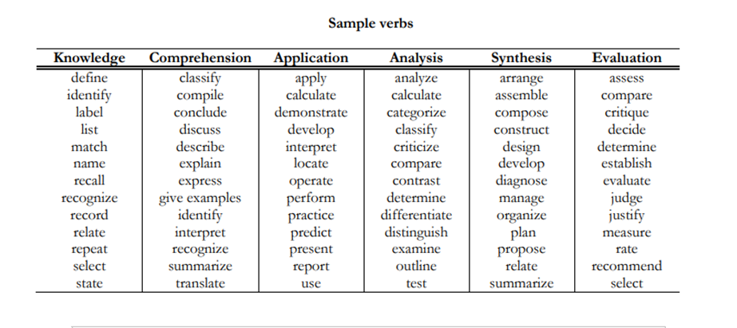

Module 6 Handout № 3
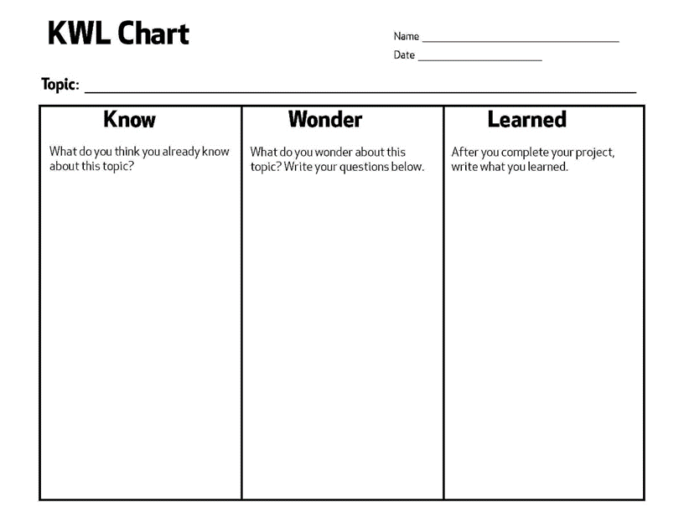

Mid - Session Reflection
​​
MODULE : Review for the first 5 Modules |  |  | Date:  Time : 1 hour (60 minutes)
By the end of the module, participants will be able to:

Language Point:
Skills: Speaking, Listening , Writing
Material: Videos, handouts, flipcharts
Stage/timing  Interaction | Activity type | Procedure
10 min  Welcome  Routines | Warm-up | Welcome Message, Agenda, Quote, Pairs,  Groups and Elbow partners & wakeup movement
10 min  Pair work | Preview | Participants share their experience about .  Tell the participants to discuss the questions with elbow partners:
15 min  Pair work | Experience –  Daily mingle activity
10 min  Individual work | Reflection | - Ask the participants to reflect on the sample activity they have experienced by answering the following questions:  Did you like this activity? Why?  How did you feel during the activity?  What have you learned from the activity?  - State that this is an example of activity. Say that effective classrooms …
25 minutes  Group work | Conceptualize | The participants will explore the ideas for by watching :
40 min  Group work | Conceptualize
15 min  Pair work | Reflect/ Experience  Mingle around activity | Example
15 minutes  Individual work | Conceptualize | Example
35 min  Group work | Apply
10 min  Pair or group work | Wrap-up | For the wrap up at the end of the session, y. Your reflective wrap-up questions can be:  •
5 min  Homework | Telegram group discussion

Agenda
9:00 - 9:10 | 7
9:10 - 9:40 | 7
10:00 - 10:30 | 7
11:00 - 12:00 | 8
12:00 - 12:40 | 8
12:40- 1:00 | 8

Welcome Message

Workshop Objectives

Lesson Plan
​​
MODULE : |  |  | Date:  Time : 3 hours (180 minutes)
By the end of the module, participants will be able to:

Language Point:
Skills: Speaking, Listening , Writing
Material: Videos, handouts, flipcharts
Stage/timing  Interaction | Activity type | Procedure
10 min  Welcome  Routines | Warm-up | Welcome Message, Agenda, Quote, Pairs,  Groups and Elbow partners & wakeup movement
10 min  Pair work | Preview | Participants share their experience about .  Tell the participants to discuss the questions with elbow partners:  - State
15 min  Pair work | Experience –
10 min  Individual work | Reflection | - Ask the participants to reflect on the sample activity they have experienced by answering the following questions:  Did you like this activity? Why?  How did you feel during the activity?  What have you learned from the activity?  - State that this is an example of activity. Say that effective classrooms …
25 minutes  Group work | Conceptualize | The participants will explore the ideas about… by…
40 min  Group work | Conceptualize
15 min  Pair work | Reflect/ Experience  Mingle around activity | Example
15 minutes  Individual work | Conceptualize | Example
35 min  Group work | Apply
10 min  Pair or group work | Wrap-up | For the wrap up at the end of the session…. Your reflective wrap-up questions can be:
5 min  Homework | Telegram group discussion

Module 7 Extending textbook activities

MODULE : 7 Extending textbook activities |  |  | Date:  Time : 3 hours (180 minutes)
By the end of the module, participants will be able to:
- analyze textbook lessons/activities and adapt content for appropriate and meaningful use
to meet the learner needs and enhance classroom interactions
- use textbook, ancillary materials, and other relevant sources to develop an effective
communicative lesson/activities appropriate for your learning environment
Language Point:
Skills: Speaking, Listening , Writing
Material: Videos, handouts, flipcharts
Stage/timing  Interaction | Activity type | Procedure
10 min  Welcome  Routines | Warm-up | "The most dangerous phrase in the language is, 'We've always done it this way!'."  - Grace Murray Hopper  There are many good teaching materials published, but even good materials are not perfect for every teaching context. With the advance of technology, especially the Internet, rich  instructional resources can also be found online. However, in order to meet the diverse needs of your teaching situations, it becomes necessary to adapt the teaching resources to deliver effective communicative instruction in English. In this module, you will have a chance to reflect on your teaching contexts and materials available to you. You will also explore ways to effectively adapt your teaching materials to foster a communicative classroom in English.
10 min  Pair work | Preview | Participants share their experience about .  Tell the participants to discuss the questions with elbow partners:  what does “adapting textbook activities” mean? And number two, why do you  need to adapt textbook activities in your context?
15 min  Pair work | Experience – | In small groups participants share their ideas about extending and adapting textbook materials. Then one member from each group tells their experience about the theme.
10 min  Individual work | Reflection | Why do you need to adapt textbook activities in your context? Here are some reasons  teachers around the world adapt their textbook materials: It’s either  • lack of time,  • lack of necessary equipment,  • curriculum requirements and/or restrictions,  • cultural issues,  • student language levels,  • lack of variety of activity types,  • boring materials, and  • lack of clear goals.
25 minutes  Group work | Conceptualize | § Video 1: Adapting Textbook Activities  o This video explains the reasons behind the necessity of adapting textbook  activities. Also, it suggest ideas on how to adapt an activity using a textbook  activity sample. Click here for the PDF of the script for Video 1.  o Link to YouTube: https://youtu.be/NWBGSjnKdpA
40 min  Group work | Conceptualize | § Video 2: Tips for Adapting Teaching Materials  o This video suggest tips on how to adapt your teaching resources to promote  communication in your English classroom. Click here for the PDF of the script for  Video 2.  o Link to YouTube: https://youtu.be/mai-Gor0wMM
15 min  Group work | Jigsaw activity | Divide into group of 4 and read the 1st article. Then return to your home group and share the parts of the text.
15 minutes  Individual work | Conceptualize | Divide into group of 4 and read the 2nd article. Then return to your home group and share the parts of the text.
35 min  Group work | Apply | In small groups choose one activity from your textbook and adapt it to make it more communicative.  Examine the teaching resources you currently use in your school, including your textbook.  Choose a picture, a reading passage, written assignments and/or practice exercises from your resource. How can these be adapted and used to give your students more chances to use their English communicatively?  OR  Consider the activities/classroom strategies presented in this module (and any others you’ve  already completed). You can also find these in the Activity Bank, as well as from the Activity Shares. How can you incorporate one or more of these strategies into your adapted  textbook/resource activities to enhance meaningful communication in your classroom?  Create an adapted textbook lesson/activity.  - Choose a lesson (or a part of a lesson) that you would like to adapt from your textbook.  - Describe your learner characteristics and teaching context. Which lesson/activity would you adapt and why? Present your newly adapted  lesson/activity. Suggestions for activity adaptation:  § Make it into a role play  § Make it into a pair/group work  § Make it into a team quiz  § Simplify the language  § Replace with a jigsaw reading  § Use an information gap activity  § Gallery walk, reflect, and comment  § What else? What has worked for you in the past?  Are there any new activities you have learned in this module (or learned recently) that you  would like to use in this textbook adaptation task
10 min  Pair or group work | Wrap-up  First individual and pair work. Speaking line | Wrap up questions.  What is adapting textbook materials?  Why do we need to adapt the materials?  How can we adapt textbook materials.  First you write it down individually and tell it to your partner. SHare ideas.
5 min  Homework | Telegram group discussion | Share the adapted lesson/activity you created in the group chat. Be sure you post an adapted  lesson/activity that you have not seen already in the group chat. Please post a brief message and  attach a Word document, PDF, or PPT slides with your activity.  Example  Hello, Colleagues! The activity I want to share to increase classroom interaction is called  __________________________________________________________ (activity title). This  activity is effective because_____________________________________________________  ________________________________________________________________. See the three  simple steps in the attached file for an example on how I use this activity in my classroom to  increase interaction. (Be sure to attach your activity file).  Write 1-2 paragraphs to reflect on Module 7 (300-500 words). You may use what you have  created, shared, and applied in the previous tasks.

Module 8: Creating and facilitating visually stimulating tasks

Welcome Message

Workshop Objectives

Lesson Plan

MODULE 8: CREATING AND FACILITATING VISUALLY STIMULATING TASK |  | City/Region:  Venue: |  | Trainer:  Number of participants: | Date:  Time : 2 hours (120 minutes)
By the end of the module, participants will be able to:
- Explore ideas for creating and facilitating visually stimulating tasks
- apply some of the new ideas for using visual tools, such as graphic organizers, for language learning in their classroom.
- share some strategies for making learning visually stimulating, such as using charts and word walls.
Language Point: CREATING AND FACILITATING VISUALLY STIMULATING TASK
Skills: Speaking, Listening , Writing
Material: Videos, handouts, flipcharts

Stage/timing  Interaction | Activity type |  | Procedure
5min. Whole group | Attention getter |  | Unscramble the words in order to get a Chinese proverb  At, to, one, is, learn, a language the, which, to, have, look, , window, one, more, from, to.
10 min  Pair work | Preview |  | Participants share their experience about creating and facilitating visually stimulating tasks they.  Tell the participants to discuss the questions with elbow partners:  - Do you have a chalkboard, whiteboard, or poster board in your classroom?  - Are you interested in challenging your students to process their language learning even further?  Elicit random answers.
15 min  Pair work | 3. Stimulate recall of prior learning |  | Tic Tac Toe game
10 min  Individual work | Reflection |  | - Ask the participants to reflect on the activity they have experienced by answering the following questions:  - Did you like this activity? Why?  - How did you feel during the activity?  - What have you learned from the activity?
25 minutes  Group work | Conceptualize  Video discussion |  | The participants will explore the ideas for Visual Tools for Language Learning in English and Strategies for Making Learning Visually Stimulating by watching two videos.  Video 1. Visual Tools for Language Learning  Tell the participants that this video will introduce some ideas for Visual tools for language learning.  Link to YouTube: https://www.youtube.com/watch?v=VFmJIBjzJ0A  Video 2. Strategies for Making Learning Visually  This video will introduce strategies of making learning visually  Link to YouTube: https://www.youtube.com/watch?v=VFmJIBjzJ0A
20 min  Group work | Guide learning |  | Article 1: Collaborative Mind Mapping by Melissa Mendelson  Thousand Word Pictures by Tabitha Kidwell
25 min  Pair work | . Elicit performance (practice) |  | Ask the participants following questions:  - Have you successfully used a visually stimulating tool, such as a concept map or another graphic organizer? If so, how was the tool a useful resource for your students for the lesson or activity? If not, then think about a lesson or activity in which your students had difficulty working with the content.  - How could using a visual tool, such as a graphic organizer, assist your students with understanding a concept more easily? How could using visuals stimulate learning for your students?  - In what ways could using visual tools challenge your students to think more critically about a topic or lesson?  After some discussions ask participants  create a new or adapt an existing activity/lesson to incorporate the use of a graphic organizer or one of the visually stimulating resources from the suggested websites in this module to assist students with their development of ideas, communication skills, and activity/assignment comprehension. This is an opportunity to learn new teaching ideas/strategies for using visually stimulating tasks from each other and enhance their practice. Use the template below when creating their activity:  Activity/Lesson Name:  Grade level / Unit (if applicable):  Activity Description:  - The purpose of this activity is to...  - This activity is effective for this lesson because…  - Here are some steps to help you use this activity in your classroom…  Step 1:  Step 2:  Step 3:
15 minutes  Individual work | Conceptualize |  | - Invite the teachers to watch the video that introduces some the graphic organizer known as the KWLQ Chart,which can be used as a pre- and/or post-formative assessment of student  learning.  - Link toYouTube :https://www.youtube.com/watch?v=VFmJIBjzJ0A  - After they watch the video ask them to analyze the activities they had in the previous stage.  - What was the purpose the KWLQ?  - Do you think that visually stimulating tasks has helped you understand the concept better?  Elicit random answers.
35 min  Group work | Apply |  | - Put the participants in small groups of three. Tell them that this module introduced several different ideas about Creating and facilitating visually stimulating tasks. Based on what you learned, create a new or adapt an existing classroom activities you would like to use regularly in your current teaching context. On the poster briefly describe who your learners are, when would you use this activity, and why you believe it would be effective. (20 minutes)  - Share the activity that you have created. You may use the following message as a template while presenting your poster. (3 minutes for each group)  Example  Hello, Colleagues! The (activity/video/routine/ instructions) we want to share is called __________________________ (activity title). This activity is effective because________________________________________________________________________________________________________________.
20 min  Pair or group work | Provide feedback |  | PQP  Participants share the activity or strategy they created in the group. After sharing they give feedback using PQP
10 min | .Enhance retention and transfer |  | After they share an activity in the group. Find at least one or two new activities in the group chat that they can use in their next class. Ask them to apply a new activity from this module in their next class. If it is a success, tell their colleague "Thank you!" and why it was effect
5 min  Individual work | Assess performance |  | Exit tickets  Participants complete exit tickets

Module 9: Facilitating discussions and debates

Welcome Message

Good morning dear trainees! Are you ready to power up your English class?

Today, we will learn about discussion activities and facilitating debates. Also, we will explore how discussions and debates can strengthen students’ language proficiency and confidence. Finally, we will design ways we plan to integrate learning activities that support a communicative approach for language learning in your classroom.
Objectives
I can describe the benefits of communicative language teaching through discussions, debates and how to use them in the EFL classroom

I can explore various cooperative learning and interactive language tasks and strategies that build language proficiency.

I can design ways I plan to integrate and manage learning activities that support a communicative approach for language learning in the classroom.
Lesson Plan

MODULE 9: Facilitating Discussions and Debates |  |  | Date:  Time: 2 hours (120 minutes)
By the end of the module, participants will be able to:
● describe the benefits of communicative language teaching through discussions, debates
● explore various cooperative learning and interactive language tasks and strategies that build language proficiency.
● design ways they plan to integrate and manage learning activities that support a communicative approach for language learning in the classroom.
Language Point: Discussions and debates
Skills: Speaking, Listening, Writing
Material: Videos, handouts, flipcharts
Stage/timing  Interaction | Activity type | Procedure
3-5 min  Individual work | Warm-up  One-minute talk | Gain the trainees’ attention with a quote: "If you talk to a man in a language he understands, that goes to his head. If you talk to him in his own language, that goes to his heart."  ‒ Nelson Mandela  - Elicit 2-3 trainees’ answers about the given quote means.  (For this facilitator may prepare SLIPS OF PAPER with trainees’ names. Mix up slips of paper, let trainees choose one by one slips of paper after each trainee’s response. Whose name is on the chosen sheet of paper needs to present his/her idea on the given quote.)
8 min  Pair work  Turn and Talk | Preview  Brainstorming | Participants share their experience about the strategies of facilitating discussions and debates in their classroom.  Tell the participants to discuss some questions with elbow partners:  1.How will you explain the instructions to your students in a comprehensible way?  2. What activity materials need to be prepared in advance?  3. How will you monitor student performance?  4. How will you check for student understanding?  5. How will you manage transitions during discussions and/or debates in your classroom?
20 min  Group work | Conceptualize  Video discussion | Video 1. Discussion Activities  Tell the participants that this video will introduce some ideas for stimulating discussions and setting expectations for these activities in the language classroom.  Link to YouTube: https://www.youtube.com/watch?v=Is2Occp53nk  Video 2. Debates in the Language Classroom  Tell the participants that this video will introduce you to some ideas for organizing and facilitating debates in the language classroom, such as Bucket of Prompts and Mock Debates.  Link to YouTube: https://www.youtube.com/watch?v=NBf3pkHwY1Y  Divide the participants into smaller groups and ask them to list topics for creating Discussion questions. (Handout 1)  Note: Trainees can count numbers from 1 to 4 and form Group 1, Group 2, Group 3 and Group 4.
15 min  Team work | Experience –  Mock Debate - Graphic Organizer activity | ● Tell the participants to act the role of school students to practice Mock debate activity. Topic: Should schools require students to wear uniforms?  ● Begin by explaining to students that the purpose of the Mock debate activity is to stimulate a real debate, but situated in the classroom. Tell students that you will divide them into two teams (Team A For and Team B Against).  ● Present a graphic organizer and explain that students can plan out their claim, reasons, evidence, counter arguments, and closing statement in advance to say in a classroom debate (Handout 2)  ● Students in Team A and Team B participate in the debate. Facilitate the debate discussion.
5 min  Individual work | Reflection | ● Ask the participants to reflect on the sample activity they have experienced by answering the following questions:  1. Did you like this activity? Why?  2. How did you feel during the activity?  3. What have you learned from the activity?
30 min  Group work | Conceptualize  Jig-saw Reading | Home group - Guest Group – Home group  Note: Facilitators may choose ONLY one article and cut it into 3 parts for Gr.1,Gr.2 and Gr.3.  Group 1. Article 1: Navigating Discussions and Debates in the EFL Classroom  Group 2. Article 2: Critiquing Questions  Group 3. Article 2: Bring it On: How to Get Students Fired Up about English with ESL Debates  Divide the participants into three groups. Tell them that this is their Home group. They will read the assigned article and discuss it in their groups. They should take notes in the table. (15 minutes)  ● Number the participants from 1 to 3. Tell them to show their number with fingers and keep their fingers up to find their group. All the participants who are number one will form one group, all the twos will form group two, so on.  ● When group members meet in the guest group (new group) they share the information they discussed in their host groups. Tell the participants to take notes in the table. (10 min) (Handout 3)  ● Ask the participants to go back to their home groups with their notes and share their findings. (10 min)  ● Ask the groups to share what they have learned about discussions, debates and critiquing questions. Elicit random responses. (5 min)
15 min  Pair work | Reflect/ Experience  Mingle around activity | Ask the participants to discuss the following questions by referring to the videos and articles they discussed. Read the questions and tell them to write the answer in their notebooks. (1 minute)  ● What do “discussions” and “debates” look like for you? How about in your classroom instruction?  ● How do you usually get students interested in discussing a new topic in your class?  ● How do you generally select the topics of discussion for class? Do students have any choice or input in selecting topics?  ● What are your challenges and possible solutions for facilitating discussions and debates in your language classroom?  When you see the participants are ready, tell them:  ●“Now, walk around the room to find a partner to share what you wrote. Please, talk at least to two peers”  ●“As you listen, write down what your partner said in your notebook.”  As you mingle around the room and listen to their conversations, you can check for participants’ understanding of the session videos and articles.  Remind the trainees that mingling is a short activity where learners walk around the classroom and talk to each other. It is an excellent activity routine to help everyone use more English in the classroom. Mingling is one of the most popular activities for language teachers and students because they are flexible. Mingling also provides more student talk time, while reducing teacher talk time. Plus, mingling allows shyer students to speak to their peers without feeling pressured to speak in front of a large class.
15 minutes  Individual work  Think- Pair- Share | Conceptualize  Reflection | ● Invite the teachers to watch the video that introduces the steps for developing higher order thinking questions that encourage critical thinking.  Link to YouTube: https://www.youtube.com/watch?v=FE8wW9jLk3g  ● After they watch the video ask them to analyze the activity they had in the previous stage.  ● What was the purpose the activity?  ● Do you think that interacting with your partner has helped you understand the concept better?  Elicit random answers using random name calling protocol such as picking random names written on a small sheets of paper or wheel of names.
5 min  Pair or group work | Wrap-up | For the wrap up at the end of the session, you can set up instructional routines such as paired or group reflection for sharing. Your reflective wrap-up questions can be:  • What is one thing that you learned today?  • What is one question that you still wonder?  • What discussion or debate activity you will apply in your class?
5 min  Homework assignment | Telegram group discussion | 1. Create a “Bucket of Prompts” activity by listing 8-10 debate or discussion topics that align with your curricula. There may already be many topics embedded in your textbook and curriculum that make for excellent debate topics. Take a look and find some!  2. Create your discussion/debate-based activity using the template (Handout 4).  Post in the Telegram group. Read your peers’ posts and comment at least to two posts by using ‘reply’ function in the Telegram chat.

Week 12

Module 10: Managing cooperative activities

Agenda
9:00 - 9:10
9:10 - 9:40
10:00 - 10:30
11:00 - 12:00
12:00 - 12:40
12:40- 1:00

Welcome Message

Workshop Objectives

Lesson Plan
​​
MODULE :  10 |  |  | Date:  Time : 3 hours (180 minutes)
By the end of the module, participants will be able to:

Language Point:
Skills: Speaking, Listening , Writing
Material: Videos, handouts, flipcharts
Stage/timing  Interaction | Activity type | Procedure
10 min  Welcome  Routines | Warm-up | Welcome Message, Agenda, Quote, Pairs,  Groups and Elbow partners & wakeup movement
10 min  Pair work | Preview | Participants share their experience about .  Tell the participants to discuss the questions with elbow partners:  - State
15 min  Pair work | Experience –
10 min  Individual work | Reflection | - Ask the participants to reflect on the sample activity they have experienced by answering the following questions:  Did you like this activity? Why?  How did you feel during the activity?  What have you learned from the activity?  - State that this is an example of activity. Say that effective classrooms …
25 minutes  Group work | Conceptualize | The participants will explore the ideas about… by…
40 min  Group work | Conceptualize
15 min  Pair work | Reflect/ Experience  Mingle around activity | Example
15 minutes  Individual work | Conceptualize | Example
35 min  Group work | Apply
10 min  Pair or group work | Wrap-up | For the wrap up at the end of the session…. Your reflective wrap-up questions can be:
5 min  Homework | Telegram group discussion

