The 6 Principles®
for
Exemplary Teaching of
English Learners

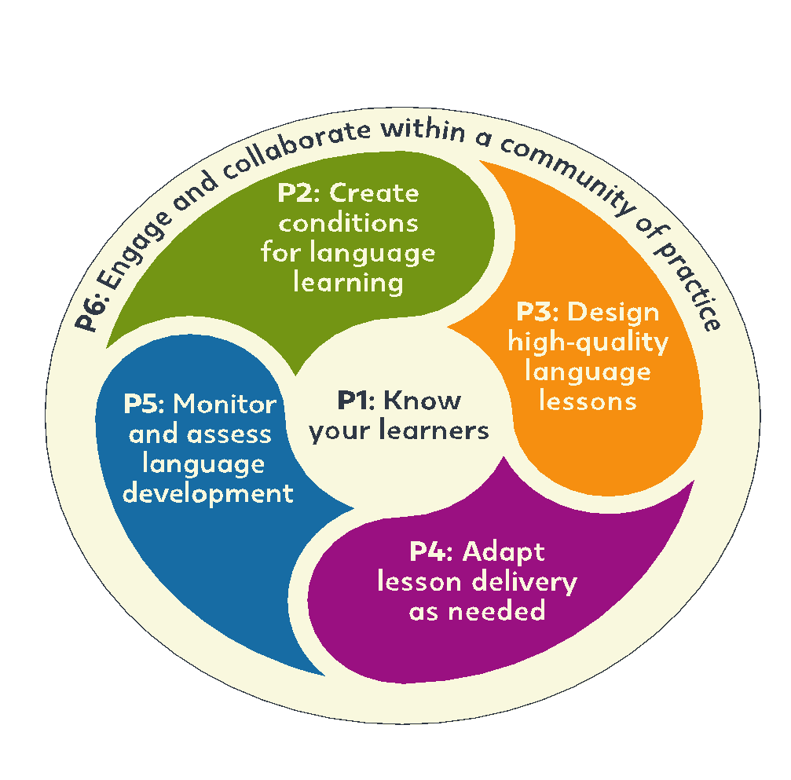

English Speaking Nation: Secondary
Teacher Training Program
Uzbekistan

ELT Leadership Development Program
September 2021

