The 6 Principles®
Overview of The 6 Principles for Exemplary Teaching of English Learners

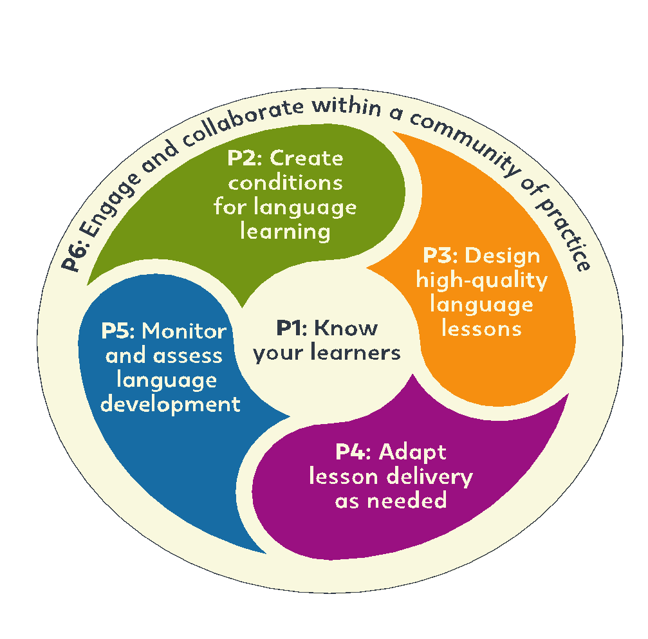

PRINCIPLE 1: Know your learners.
- Best Practice 1: Teachers collect information about their students.
- Best Practice 2: Teachers plan lessons to collect and use information about students.

PRINCIPLE 2: Create conditions for language learning.
- Best Practice 1: Teachers create a positive and organized classroom where students feel happy and comfortable.
- Best Practice 2: Teachers demonstrate that they have high expectations of all students.
- Best Practice 3: Teachers plan lessons that motivate students.

PRINCIPLE 3: Design high-quality lessons for language development.
- Best Practice 1: Teachers prepare lessons with clear language objectives and share the objectives with their students.
- Best Practice 2: Teachers use oral and written English that students can understand.
- Best Practice 3: Teachers have active classrooms where students can actively practice English with interesting topics.

PRINCIPLE 4: Adapt lesson delivery as needed.
- Best Practice 1: Teachers check student understanding often.
- Best Practice 2: Teachers adapt their teaching when it is necessary.

PRINCIPLE 5: Monitor and assess student language development.
- Best Practice 1: Teachers take notes of student errors.
- Best Practice 2: Teachers give prompts and specific feedback to students in a positive and effective way.
- Best Practice 3: Teachers use a variety of assessments to inform teaching and improve learning.

PRINCIPLE 6: Engage and collaborate within a community of practice.
- Best Practice 1: Teachers regularly do self-reflection.
- Best Practice 2: Teachers regularly participate in professional development.

