TOT: Week 9 - Room 1 - Group 1

See the Action Plan document for feedback about this workshop plan as well as your action plan.
~ From the George Mason University Academic Team

Workshop Training Plan Template
Workshop Title: Module 9- Facilitating discussions and debates
Workshop Description: In this module, you will explore how discussions and debates can strengthen students’ language proficiency and confidence. These are two forms of communication that also encourage critical thinking and build intercultural competence.
Gagné’s Nine Events of Instruction |  | Time
1. Gain attention | Topic: Should schools require students to wear uniforms?  Activity: “Four corners”: Agree/disagree/strongly agree/strongly disagree. | 20  minutes
2. Inform learners of objectives | By the end of this module, you will be able to:  - describe the benefits of communicative language teaching through discussions and debates and how to use them in the EFL classroom  - explore various cooperative learning and interactive language tasks and strategies that build language proficiency and a classroom discourse community  - develop higher order thinking questions that encourage critical thinking in the classroom  - design ways you plan to integrate and manage learning activities that support a communicative approach for language learning in your classroom | 10 minutes
3. Stimulate recall of prior learning | Group discussion:  - What do “discussions” and “debates” look like for you? How about in your classroom instruction?  - How do you usually get students interested in discussing a new topic in your class?  - How do you generally select the topics of discussion for class? Do students have any choice or input in selecting topics?  - What are your challenges and possible solutions for facilitating discussions and debates in your language classroom? | 25 minutes
4. Present the content | - watch 3 videos for facilitating discussions and debates  - provide a reading passage and to create HOT questions  - apply “Tower Build “ activity for stimulating discussions  - read the article and collect information through Jigsaw activity | 50 minutes
5. Guide learning | One activity for stimulating discussions is called Tower Build. This conversation-based discussion activity gives students the opportunity to negotiate meaning and encourage one another to stay on the same topic. Put 3-4 students in one group to optimize participation and engagement. Give students cubes, such as Legos or another sort of stacking item, which they use to build a tower as they contribute to the conversation. When they add an idea, agree, disagree, or ask a question to a group member, they will add an item to their tower. One member of the group starts the conversation with a statement or question about a topic.  Topics can be prepared in advance. The goal is to keep the conversation going until no one has anything else to say. Each member will add a cube to the tower for contributing to the conversation. Students can be assigned a specific-colored cube and encouraged to use targeted vocabulary, grammatical structures, or expressions to add additional cubes to the tower. This activity can also be used as a formative assessment as a visual representation of students’ participation for their contribution to the tower they build. At the end of the activity, you can see whose tower is the highest in the class!  Participants can work with stickers instead of cubes and build their towers on posters. There can be a picture of a tower on stickers and stickers can be of two colours to express their agreement or disagreement about the topic.  After watching Video 2- participants perform “Mock Debate” based on any topic that interests them. They will be divided into 2 teams and present their claim and evidence to support their ideas.  Based on Video 3 content participants look at the question examples and working in small groups choose any topic and make their own question examples.  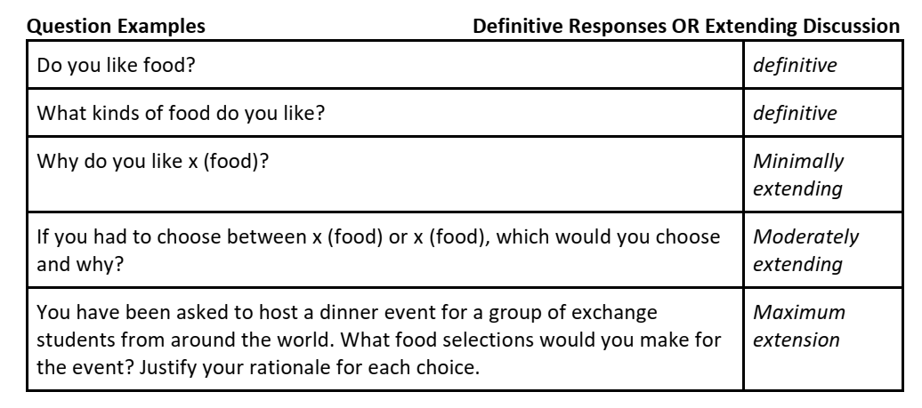 | 60 minutes
6. Elicit performance (practice) | Ask students:  • Did the question stimulate much discussion? Why? Why not?  • How could the question be improved to be a better discussion question?  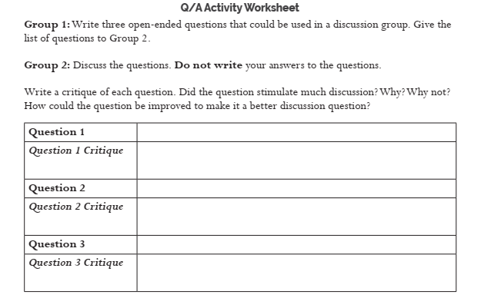  -Create a list of debate topics that align with your curricula. Post a “Bucket of Prompts”. (individually) |  | 35  minutes
7. Provide feedback | PQP based on the group presentations. |  | 20  minutes
8. Assess performance | Participants fill in their foldables. |  | 15 minutes
9. Enhance retention and transfer | Before participants leave the workshops, ask them to write 3 things they have learned today. |  | 15 minutes

